Annual Report
2024-25
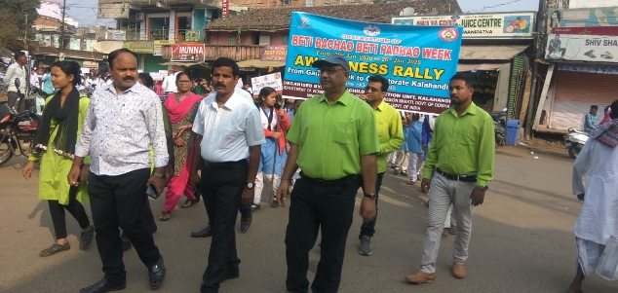
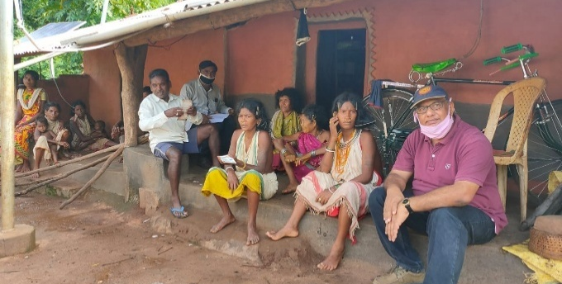

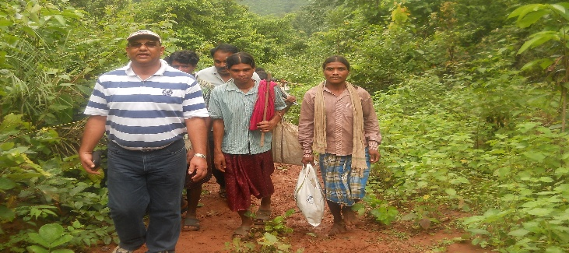
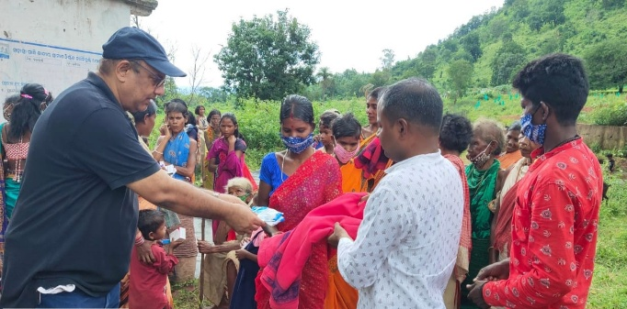

DAPTA
Development Agency for Poor & Tribal Awakening,
Bhawanipatna, Kalahandi
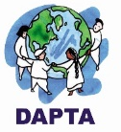
Contents

- Vision, Mission and Geographical Area
- Donor Wise Activities in 2021-22
- Thematic area of Intervention
- Executive Body Details
- Staff Details
- Training Facilities and Trainers Associated with DAPTA
- Legal Entity
- Audited Statement -Attached Separate Sheet.

Secretary’s Desk……….

DAPTA’s strong commitment to uplift poor, tribal and women makes it a distinctive civil society organization. Being associated with DAPTA from its inception gives me immense pleasure, especially when I see the poor, tribal and women becoming more aware of their rights and taking charge of their own development.

I am very glad to present the Annual report of 2021-2022 in which year the organization has completed its 32nd eventful journey. DAPTA, a development support organization, has diversified its journey in sustainable development of down trodden people, marginal community with a special' focus to the development of women, children and tribal people of Kalahandi and other tribal areas of Odisha since its inception.

DAPTA is working on four numbers of issues like Women empowerment', Agriculture and livelihood, Health care, Education child right and Humanitarian supports. Witnessing ground reality ‘we are working with some other network partners. DAPTA usually work for the people with community participation, community involvement and community led evaluation process to lead a sustainable change. This Year DAPTA has covered a large number of women, children and farmers mostly in its all project'. I am proud to say that DAPTA has set new goals for the next five years under the Country Strategy-V as a commitment to achieving the Sustainable Development Goals. It aims to bring a positive impact in the lives of the marginalized (poor, tribes, women and transgender) by 2025. This will be achieved through support from key partners including corporates, government, donors and civil society organizations. I am confident that we will achieve this goal.

On behalf of DAPTA, I express my deep gratitude to all our donors like SWL, Central social Welfare Board. State Social Welfare Board, Azim Premji Foundation, Reliance Foundation, NABARD, OSACS, TDH Germany, Barefoot College, Selco foundation, Smile Foundation, CHILDLINE India Foundation, Habitat India, Jiv Daya Foundation, CHILDLINE India Foundation, ChildFund India, SSPD Dept., WCD Dept. Millet Mission, Health Dept. and other donor partners. Moreover, we are grateful to Dist. Administration, Block Administration of Kalahandi and other Dist., NGO partners, WASSAN, CACL, LASK, Credibility Alliance, Guide Star, India Donates, FMSF, individuals, journalists, friends and associates those have supported DAPTA to achieve its objective and to touch the mile stone which is yet to achieve, yet to run miles and miles.........

Aadarsh Sharma
Secretary DAPTA

Vision
DAPTA’s vision is to eradicate poverty from the earth and to provide equal opportunity to all people
DAPTA’s vision is that marginalized poor in India can live without poverty and access to equal opportunities.
Mission
DAPTA’s Mission is to work with marginalized poor to alleviate poverty by overcoming injustice and inequity that causes it and to lead a meaningful life with sustainable protected environment and bio-diversity.
Geographical Area Covered
- Kalahandi District:
Block - 13
Gram Panchayat (G. P) - 97
- Mayurbhanj District:
Block - 1
Gram Panchayat (G. P) -1
- Deogarh District
Block – 1
Gram Panchayat (G. P) -1
- Nuapada District
Block – 1
Gram Panchayat (G.P) - 1
- Women Empowerment
- E-SHAKTI
- FCC (Family Counselling Centre)
- Domestic violence and adolescent trafficking
- Livelihood and Food Security
- Special Program for Promotion of Millet in Tribal Area of Odisha
- Women Farmers Producer Company, LEDP, Rural Mart
- Strengthening women’s Vegetable Grower Cooperatives
- Bee keeping
- Health for All
- Community Health and Education Program for PVTG Community.
- HIV/AIDS with Transgender Community (T.I. Project)
- Community Mental Health Care (Follow-up)
- Old Age Care
- Education & Child protection
- Mission Education Project
- CHILDLINE Service, Kalahandi
- Humanitarian Support
- COVID Food Relief and Vaccination Program.
- Cloth Distribution to Needy People

DONOR WISE ACTIVITY IN 2024-25

Sl. No | DONOR | ACTIVITY | AREA OF PROGRAMME
1. | Sight Savers | Computer Education to Visually Challenge person. | Bhawanipatna Block, Kalahandi District.
2. | Reliance Foundation | Improving the self-Reliance and Resilience of Rural communities | Bhawanipatna, Lanjigarh, Th.Rampur in Kalahandi District.
3. | Millet Mission and Dept. of Agriculture, Govt. of Odisha | Intensive Millet Promotion Activities in Tribal Areas | Bhawanipatna Block of Kalahandi District  Golamunda Block of Kalahandi District.
4. | Target Intervention  Odisha State Aids Control Society (OSACS) | HIV/Aids and STI prevention Program. | Bhawanipatna, Junagarh, Jayapatna, Dharamagarh and Lanjigarh.
5. | Mennonite Central Committee | Ensuring food and livelihood security of indigenous and other marginalized Communities | Thakurmunda Block, Mayurbhanj District, Odisha
6. | SLCW, Switzerland | Promoting Women Organization to combat domestic violence & anti-trafficking. | Kalahandi District
7. | Central Social Welfare Board, Govt. of India | Family Counseling Centre | Kalahandi District
8. | TDH Germany | Strengthening food sovereignty for indigenous communities through a community-based gender initiative and participatory food security model based on traditional knowledge. | 6 GP of Lanjigarh Block, Kalahandi.
9. | Smile Foundation of India. | Non-formal Education and  Nutrition | 132 deprived Children in 3 no of learning  Center of Lanjigarh Block.
10. | Department of Animal Husbandry, Govt of Odisha. | Animal Helpline- 1962 | Bhawanipatna Block of Kalahandi District.
11. | Child Fund India | Protecting the rights of children by building resilience of 2000 vulnerable household in Odisha. | 44 villages in Dharamagarh, Kalahandi District & Borden, Nuapada District.

SIGHTSAVERS
Supported by Madison Resource Foundation

PROJECT BACKGROUND:
The project envisages to collaborate with Tanya Computer Centre (TCC) and establish training centers across 6 states and 10 potential locations of India, where Sights Savers has been working for a long time. With this, the project aims to provide a free & certified computer training course to people with visual impairment who are above 15th years of age group and belongs to poor and disadvantage communities.
OBJECTIVE:
To build capacities of people with visual disabilities in digital literacy in the potential locations
To enhance the confidence and communication skills of the target group through personality development sessions
To create a scope for the people with visual disabilities to get meaningful employment opportunities in their local area.

INTRODUCTION:
Sightsavers with support from Madison Resource Foundation inaugurated Tanya Computer Centre (TCC) that will serve as the home to the Digital Literacy and Internet Awareness Course for children with visual impairment (CVI) in district Kalahandi of Odisha in collaboration with DAPTA. The center was formally inaugurated by the district social security officer (DSSO), Kalahandi on 13th October 2022.
Tanya Computer Centre aims to provide a free and certified computer training course to children with visual impairment (CVI), above 15 years of age and belonging to poor and disadvantage communities. This center is initiated to build the capacities of CVI in digital literacy and personality development. Apart from computer skills, the center will also impart training in spoken English, personality development, health & hygiene, mobility & daily living skills. It is envisaged that the course provided in the center will help in enhancing the confidence and communication skills of CVIs. It will equip them with required skills, tools, and assistance they need to earn a living and lead an independent life with dignity.

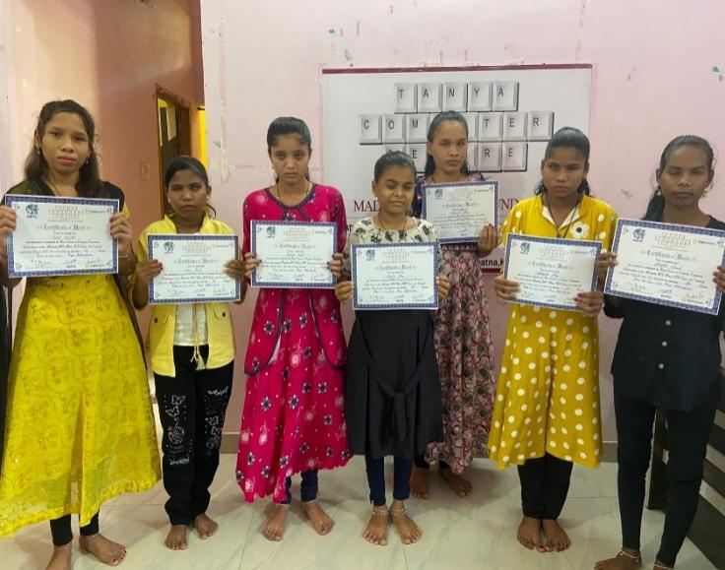
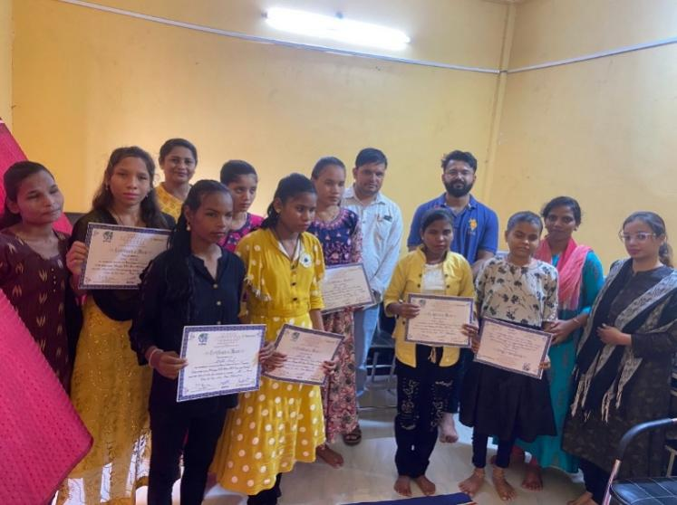
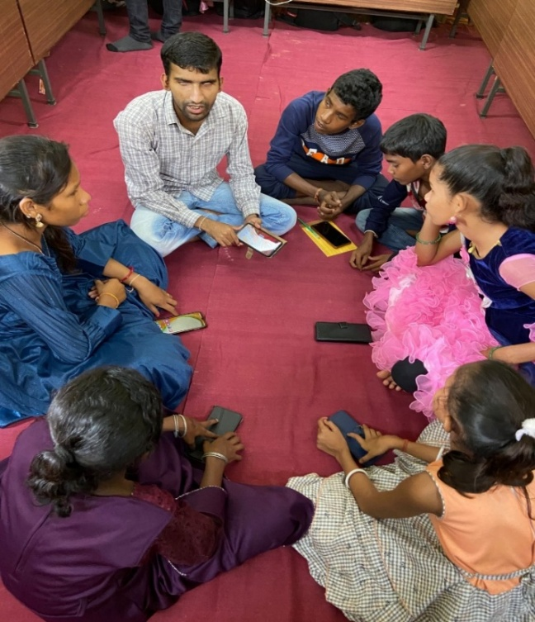
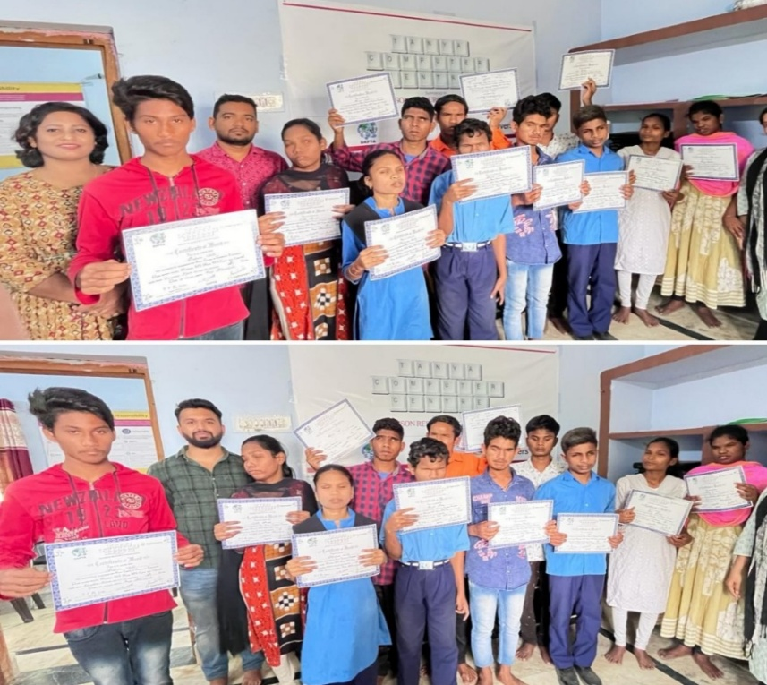
CASE STORY OF SUMANTA MAJHI:
VOCATIONAL TRAINING: Sumanta Majhi, a fully blind student from Bankapalash, Junagarh Block, is an inspiring example of determination and resilience. Despite having limited formal education, Sumanta was eager to acquire new skills and improve his socio-economic status. His interest in computers led him to enroll in a 6-month course at Tanya Computer Centre.
RESOURCE SUPPORT: The training program equipped Sumanta with valuable skills, including computer operation and basic troubleshooting. His newfound expertise sparked a desire to start his own business. However, he faced a significant challenge: lack of resources. To overcome this hurdle, Sumanta applied for a printer from the Selco Foundation, an organization that supports innovative projects.
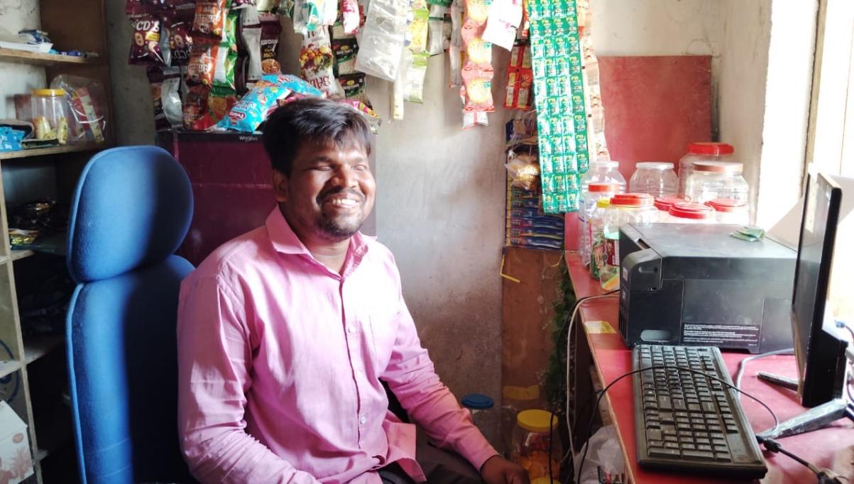
The printer proved to be a game-changer for Sumanta. He began offering printing and scanning services to the local villagers, leveraging his computer skills to provide a valuable service. This entrepreneurial venture not only generated income but also helped Sumanta become a respected member of his community.
ENTREPRENEURIAL SPIRIT: Building on the success of his printing business, Sumanta expanded his operations by opening a small shop selling daily essentials, chips, and chocolates. This diversification strategy allowed him to cater to a broader customer base and increase his earnings.
COMMUNITY IMPACT: Today, Sumanta Majhi is a proud and independent business owner, thanks to the skills he acquired at Tanya Computer Centre and the support he received from the Selco Foundation. His story serves as a testament to the impact of vocational training and resource support on the lives of visually impaired individuals.
MOTIVATIONAL LEARNINGS:
Introduction to learning Digital Literacy has opened scope for students from rural areas towards wider career opportunities.
Involvement of Government departments has increased their buy-in and support towards future employment opportunities.
Engagement of students attending TCC in extracurricular activities.

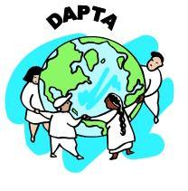

IMPROVING THE SELF-RELIANCE AND RESILIENCE OF RURAL COMMUNITIES, Supported by Reliance Foundation

PROJECT AIM:
The project will help to improve climate adaptive farming practices, end malnutrition by adopting nutritional backyard kitchen garden, conservation and management of water & soil, improving existing livelihood for better income generation of rural communities and strengthen food security in the district of Kalahandi.
AREA OF INTERVENTION:
Project Name: “Improving the self-reliance and resilience of rural communities in Kalahandi District”
Outreach: 153 Villages from 3 block of Kalahandi district.
Project Activities
Key Activities Implemented
Deviation from the original targets set for the Period
Key challenges faced
Project outputs
Project outputs achieved as per
MoU
Output Description | Phy Plan Annual | Phy Ach Annual | Money Leveraged  Through convergence
1.1-Villages initiated climate resilience measures and integrated into village/Gram Panchayat Development Plan | 30 | 30
2.1-Villages conducted participatory assessment of common resources and creating management plan | 50 | 38
2.2-Additional water harvesting capacity created | 5 | 2.0 | 10564730
2.3-Area brought under efficient management of water | 50 | 31.78 | 595200
2.4-Area covered with conservation and restoration of common resources | 200 | 252 | 280000
2.5-Villages with improved access to drinking water | 20 | 11
2.6-Households engaged in grey water management | 500 | 192 | 244000
2.7-Area brought under climate adaptive farming practices (soil fertility improvement, resistant seed, intercrop, trap crops and INM) | 1000 | 890 | 182400
3.1-Households with diversified food production and consumption | 1050 | 1052
3.2-Area covered under nutrition rich and bio fortified crops | 200 | 148 | 500000
4.1-Area under improved production practices/new agriculture technologies | 900 | 904
4.2-Farmers adopting and benefitting with improved practices and/or new agriculture technologies | 1200 | 2141
5.1-Farmer collectives (FPOs/ SHG Federations/Co-op/ PACS/ Informal group of farmers) provided techno-managerial support and/or linkages | 3 | 3
5.2-Producers benefitting from marketing of their produce / accessing products and services from Farmer Collectives | 1500 | 1224
5.3-Value of produce marketed and inputs/services sourced through farmer collectives | 2 | 1.54
6.1-No. of SHGs/ Producer Groups / Collectives (Men & Women) engaged for income enhancement | 150 | 213
6.2-Persons supported to improve existing livelihood / Persons supported in taking up additional livelihood in Farm & Non-Farm Sector | 1500 | 1156
7.1-Improved access to entitlements, schemes and financial products for financial inclusion | 1600 | 931
7.2-Women  with improved digital and financial literacy engaged in livelihood activities | 1550 | 1142
Best Practices
- During the reporting period, several innovative and impactful practices were implemented across the project villages to ensure sustainable livelihoods, ecological balance, and improved community resilience. Below is a comprehensive narration of the major initiatives:
- 1. Goat Cluster Development
- To enhance goatery interventions, two dedicated goat clusters were developed based on geographic suitability and local need assessments. These clusters aim to ensure better outreach at the household level through the formation of village-level goat producer groups. At the block level, a cluster committee was formed, comprising Extension Cadres, Presidents of Producer Groups (PGs), and Extension Workers. This decentralized and participatory governance mechanism has emerged as a best practice in strengthening goatery-based livelihoods.
- 2. Fish Cluster Development
- Cluster-based fish farming is a new initiative in Kalahandi district, adopted to boost efficiency and skill among fish farmers. Composite fish farming techniques were introduced through hands-on training sessions. Furthermore, the creation of a specialized fish cadre, called "Machya Sakhi", has played a vital role in improving fish culture practices. These cadres were trained in critical technical aspects such as plankton testing, pH testing, sampling methods, fish feed preparation, and disease identification—enhancing overall productivity in fish farming.
- 3. Promotion of Technology in Farming
- To reduce dependency on chemical inputs and promote eco-friendly farming, several technologies were introduced. Tools such as solar light traps, solar sprayers, yellow sticky traps, and pheromone traps were widely used in crops like vegetables, paddy, Kandul (pigeon pea), and green gram for pest and disease control. These technologies not only improved crop health but also reduced environmental damage, becoming a widely appreciated best practice among farmers.
- 4. Awareness through IEC Materials
- To strengthen awareness and knowledge at the grassroots level, strategic Information, Education, and Communication (IEC) materials were introduced under various thematic areas like CR4SD, DRIWE, and IVCD. These included digital wall paintings, brochures, and posters developed in simple and local languages to enhance comprehension and participation among community members.
- 5. Coordination with Line Departments and Resource Leverage
- Strong inter-departmental coordination was fostered to mobilize resources and implement activities such as construction of farm ponds, TCBs, staggered trenches, Basudha tanks, hand pump repairs, and organization of vaccination and health camps. Subsidy support for fish and goat farmers was also ensured. Collaborations with departments like Veterinary, NREGA, ITDA, Agriculture, and Horticulture significantly boosted the effectiveness and sustainability of these initiatives.
- 6. Promotion of Organic Agriculture Practices
- A major shift was made toward promoting organic and climate-resilient farming. Organic growth promoters like Stim Rich, Organic Nitrogen, Sagarika, Nano DAP, and Nano Urea were promoted in crops such as paddy, pulses, vegetables, and horticultural produce. These natural inputs not only lowered production costs but also helped maintain soil health and ecological stability—making them ideal for climate-resilient agriculture.
7. Grey Water Management through Leach Pits
- A significant improvement in grey water management was introduced through the promotion of leach pits over conventional soak pits. In regions with hard soil, soak pits were ineffective due to poor absorption and overflow issues. Leach pits have proven to be more efficient, aligning better with the local soil and topography. This innovation has emerged as a replicable best practice in managing household wastewater.

SPECIAL PROGRAMME FOR PROMOTION OF MILLETS IN TRIBAL AREAS OF ODISHA
BLOCK-BHAWANIPATNA & GOLAMUNDA
Supported by Millet Mission Govt. of Odisha

Name of the project: -Special Programme for Promotion of Odisha
Them- Livelihood & Agriculture
Block-Bhawanipatna

Project Background:
Shree Anna Abhiyan a flagship programme of the Government of Odisha, Special Programme for Promotion of Millets in Tribal Areas of Odisha (Shree Anna Abhiyan) was launched by Govt of Odisha in 2017 to revive millets in farms and on plates. To promote millets in its tribal areas is being implemented in Kalahandi district since Kharif 2017. It emerged from a consultation between Government, Academia (NCDS) and Civil Society Organisations (RRA Network, ASHA Network and local NGOs). It is first of its kind of agriculture programme with priority on increasing consumptions in Odisha.

The program has evolved after state level consultations on the subject and mitigate drought in Southern Odisha held on January 2016 by Planning and Convergence Department, Government of Odisha of NCDS, Bhubaneswar and multiple stakeholders. We ware started the programme on 1st January-2018 from DAPTA, Bhawanipatna has one of FA-Facilitating Agency and FPO-Dukuri Women Farmers Producer Company Ltd.

This comprehensive project includes campaigns for revivals of millets in household consumption, improving productivity of millet crop systems, promoting local processing enterprises and developing markets.

Project Objective: -
- Increasing household consumption of millets by about 25% to enhance. household nutrition security and to create demand for millets with focus on women and children.
- Promoting millet processing enterprises at Gram Panchayats and Block level to ease processing at households and for value added markets.
- Improving productivity of millets crop systems and make them profitable.
- Development millet enterprises and establishing market linkages to rural / urban markets with focus on women entrepreneurs.
- Inclusion of millet in State nutrition programs and public distribution system.
- To promote organic farming on Millets.
- To get more net profit.
- To prevent labour migration.
- To utilize family labour properly.
- To utilize highlands and unutilized lands.
- To improve livelihoods of the farmers.
- To skill development of farmers on nutrient value of Millets.

INFORMATION OF ACHIEVEMENT-2024-25 UNDER SHREE ANNA ABHIYAN, BHAWANIPATNA BLOCK, DISTRICT-KALAHANDI

Area of operation/Geographical area:

We worked in 192 nos. of villages of 28 GPs in Bhawanipatna block of Kalahandi district in 2024-2025.

Number of Beneficiaries reached out-
In finance year 2024-2025 reach
hed out 1809 nos. of millet farmers.
Details mentioned below-
Year | Area Achievement (in hector.) |  | Total Millet Farmers
2024-25 | Kharif | 1223.6 | 1809
2024-25 | Rabi | 10 | 16
N: B. | Total 5829.64 quintal of Ragi procurement from Millet farmers in Bhawanipatna block (KMS-2024-25).

Achievements
 | Achievement
Year | Season | Crop | Agronomic Practices | Area in hectares.
2024-2025 | KHARIF | Ragi | SMI | 208
2024-2025 | KHARIF | Ragi | LT/LS | 765
2024-2025 | KHARIF | Guruji | LS | 250.6
2024-2025 | RABI | Ragi | LS | 10
TOTAL |  |  |  | 1233.6

Major activities and outputs/major achievements of the project in 2024-25:
We organized different capacity building trainings & Activities (list given below): -
- 5 Nos of 2 Days Non-Residential Training on CRP & Progressive Farmers organized.
- 2 Days Non-Residential Training within District for 10-member women campaign team.
- 16 Days Campaigns in villages to increase awareness on household consumption of millets (Millets Ratha).
- 2 Days Block Level Training and Orientation of the CBO on community seed centre management.
- 6 nos. of 2 Days Non-Residential Training of Trainers within district on System of Millet Intensification (SMI) organized.
- 50 nos. of Crop Cutting cum Field Day programme organized at field level.
- 101 nos. of farmer’s mitting at village level for millets farmers selection and awareness meeting organized in different village of Bhawanipatna block.
- Exposure Visit of Seed Production & Safe Seed Storage for Progressive Farmers - This exposure visits not only enhanced the farmers' understanding of millet production but also encouraged community engagement and the implementation of best practices in their local farming systems. The collective experiences shared will undoubtedly contribute to improving seed production in their respective areas.
- Non-Pesticides Management training to farmers for organic farming- We practically demonstrate on preparation of Bijamruta, Jivamruta & Handikhata in different villages. The millet farmers are actively participated in the programme. They also used or spraying it on Ragi Nursery bed & result also is very excellent. Many Ragi farmers are used the technique to his different crops also.
- Training and capacity build on Ragi Nursery bed raise.
- 2 hectors of seed production field prepared and farmer selection.
- Training on Ragi transplanting & weeding.
- Crop Diversity Blocks (CDB) play a crucial role in conserving and promoting traditional seed varieties, ensuring biodiversity, and enhancing climate resilience in agriculture.
- Organized Procurement plan with Farmers Producer Company Ltd (FPO) &Tribal Development Cooperative Corporation of Odisha (TDCCOL) & monitoring the protocol.
- 2 Days Non-Residential Training of NGO staff, CRPS and Progressive Farmers on Mobile Application Documentation and Data Generation.
- 4 nos. of Community Seed Centre management.
- 4 nos. of Community Hiring centre management.
- Plan for installation of Ragi Processing Unit.
- Convergency and selected the SHG for Millet tiffin centre with ICDS & Odisha Livelihood mission.
- FPO- Dukuri Women Farmers Producer Company Ltd has registered with National Agriculture Market (eNAM) and NCDEX e-Markets Limited (NeML).
- FPO-DWFPCoL has received seed licence from Department of Agriculture & farmers Empowerment, Government of Odisha.
- FPO -DWFPCoL has signed MoU with TDCCoL, Kalahandi and CDAO cum PD-ATMA for empanelment as Procurement Agency during KMS-2024-25.

Support to Millet Farmers & SHGs
- Incentive deposited to all 1598 millet farmers by PD ATMA Shree Anna Abhiyan programme.
- Provide agricultural equipments through CHC centres those are- Cycle weeder, sprayer, plastic drum under Shree Anna Abhiyan Programme.
- Provide 4 nos. of Ragi Thresher to 4 nos. of SHGs.
- Provide Solar powered ragi processing unit to FPO with the support of SELCO Foundation.

Project Activities Inputs and Impact

Inputs | Impact
Campaigns in villages to increase awareness on household consumption of millets. | Increasing organic farming on different types of millets and their nutritive values
Exposure Visit of Seed Production & Safe Seed Storage for Progressive Farmers. | This exposure visits not only enhanced the farmers' understanding of millet production but also encouraged community engagement and the implementation of best practices in their local farming systems. The collective experiences shared will undoubtedly contribute to improving seed production in their respective areas.
System of Millet Intensification (SMI) training to Millet Farmers | More production of millet and learning the skills, revivals of millets and increasing utilization of land with get more net profit.
Millet food Festival | To promote millet-based cooked recipes and ready-to-eat foods such as bakery items, Capacity to different millets recipe preparation.
Skill development of farmers on nutrient value of Millets in Field Day. | Increasing household consumption of millets to enhance household nutrition security and to create demand for millets with focus on women and children.
Crop Diversity Block (CDB) | Crop Diversity Blocks (CDB) play a crucial role in conserving and promoting traditional seed varieties, ensuring biodiversity, and enhancing climate resilience in agriculture. A dedicated CDB field has been established, showcasing 14 different seeds varieties under three major categories: Pulses, Oilseeds, and Millets. This initiative aims to promote sustainable farming, improve soil health, and support local farmers in reviving traditional crops.
Improving productivity of millets crop systems and make them profitable. | Improve livelihoods of the farmers & Prevent labour migration and Utilize family labour properly
Training of entrepreneurs, farmers, CRPs on millet processing, packing, value addition etc and linkages with Banks and Government schemes | Promoting millet processing enterprises at Gram Panchayats and Block level to ease processing at households and for value added markets with focus on women entrepreneurs and SHGs.
Forgotten Food Festival -2024-25 | it was a step towards preserving and promoting a resilient food culture rooted in tradition and sustainability. By bringing together multiple stakeholders, the event laid the groundwork for long-term initiatives focused on health, agriculture, and cultural preservation. The collective efforts showcased at this festival have the potential to inspire similar events and campaigns across the region, ensuring that these invaluable food traditions are remembered.

Way forward-How will the community take the initiative forward beyond the project: -

Perhaps one of the most important solutions is to encourage cotton farmers to diversify into millet production after careful feasibility studies and feedback from the farmers themselves. Traditionally, the region of Kalahandi was rich in millet cultivation, and more so because of its predominant rain-fed agricultural landscape. Such an inclusive policy will protect the rights of the average farmer, who are under stress and debt due to the expensive cotton economics, and help women farmers engage in productive agriculture.

Strategies should be developed for increasing the involvement of the PRI members in the programme. Promote the other millets and demand for MSP of non-ragi millets and inclusion in the procurement channel. Development of e-marketing platforms for millet and FPOs.
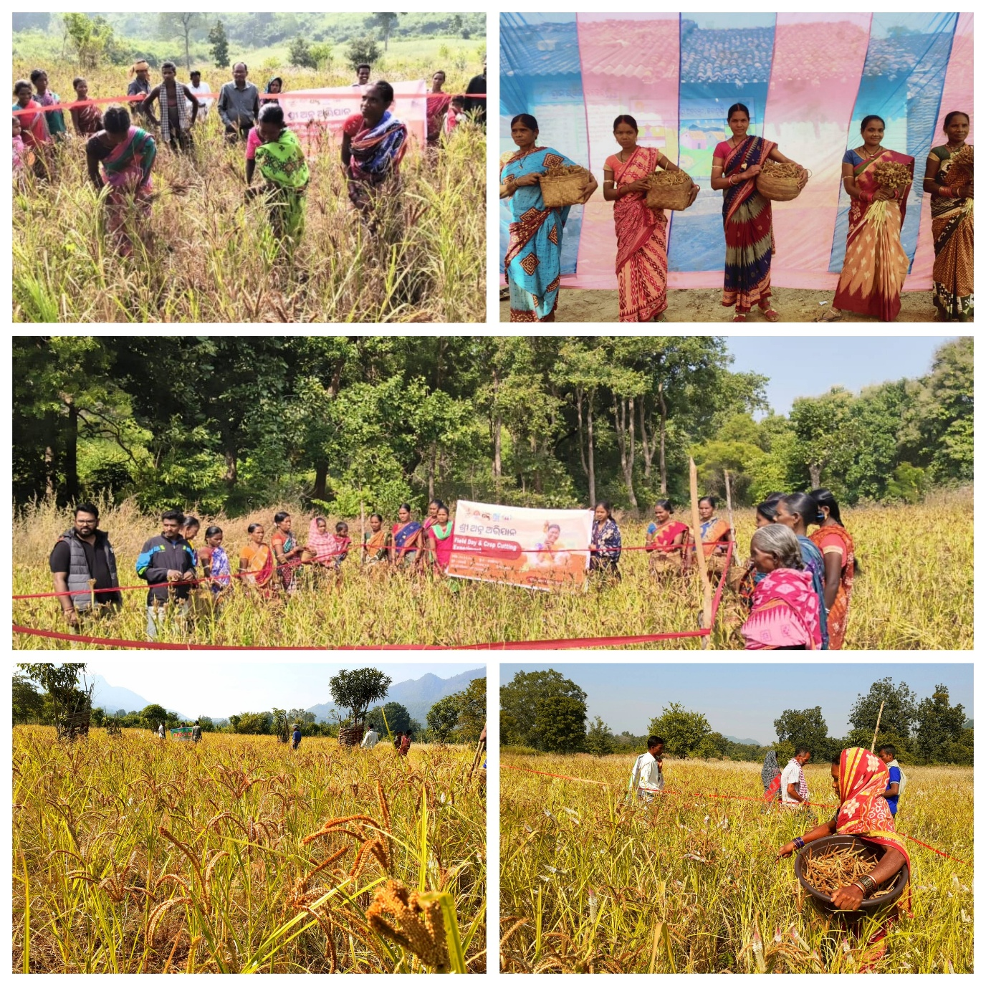
PHOTO GALLERY

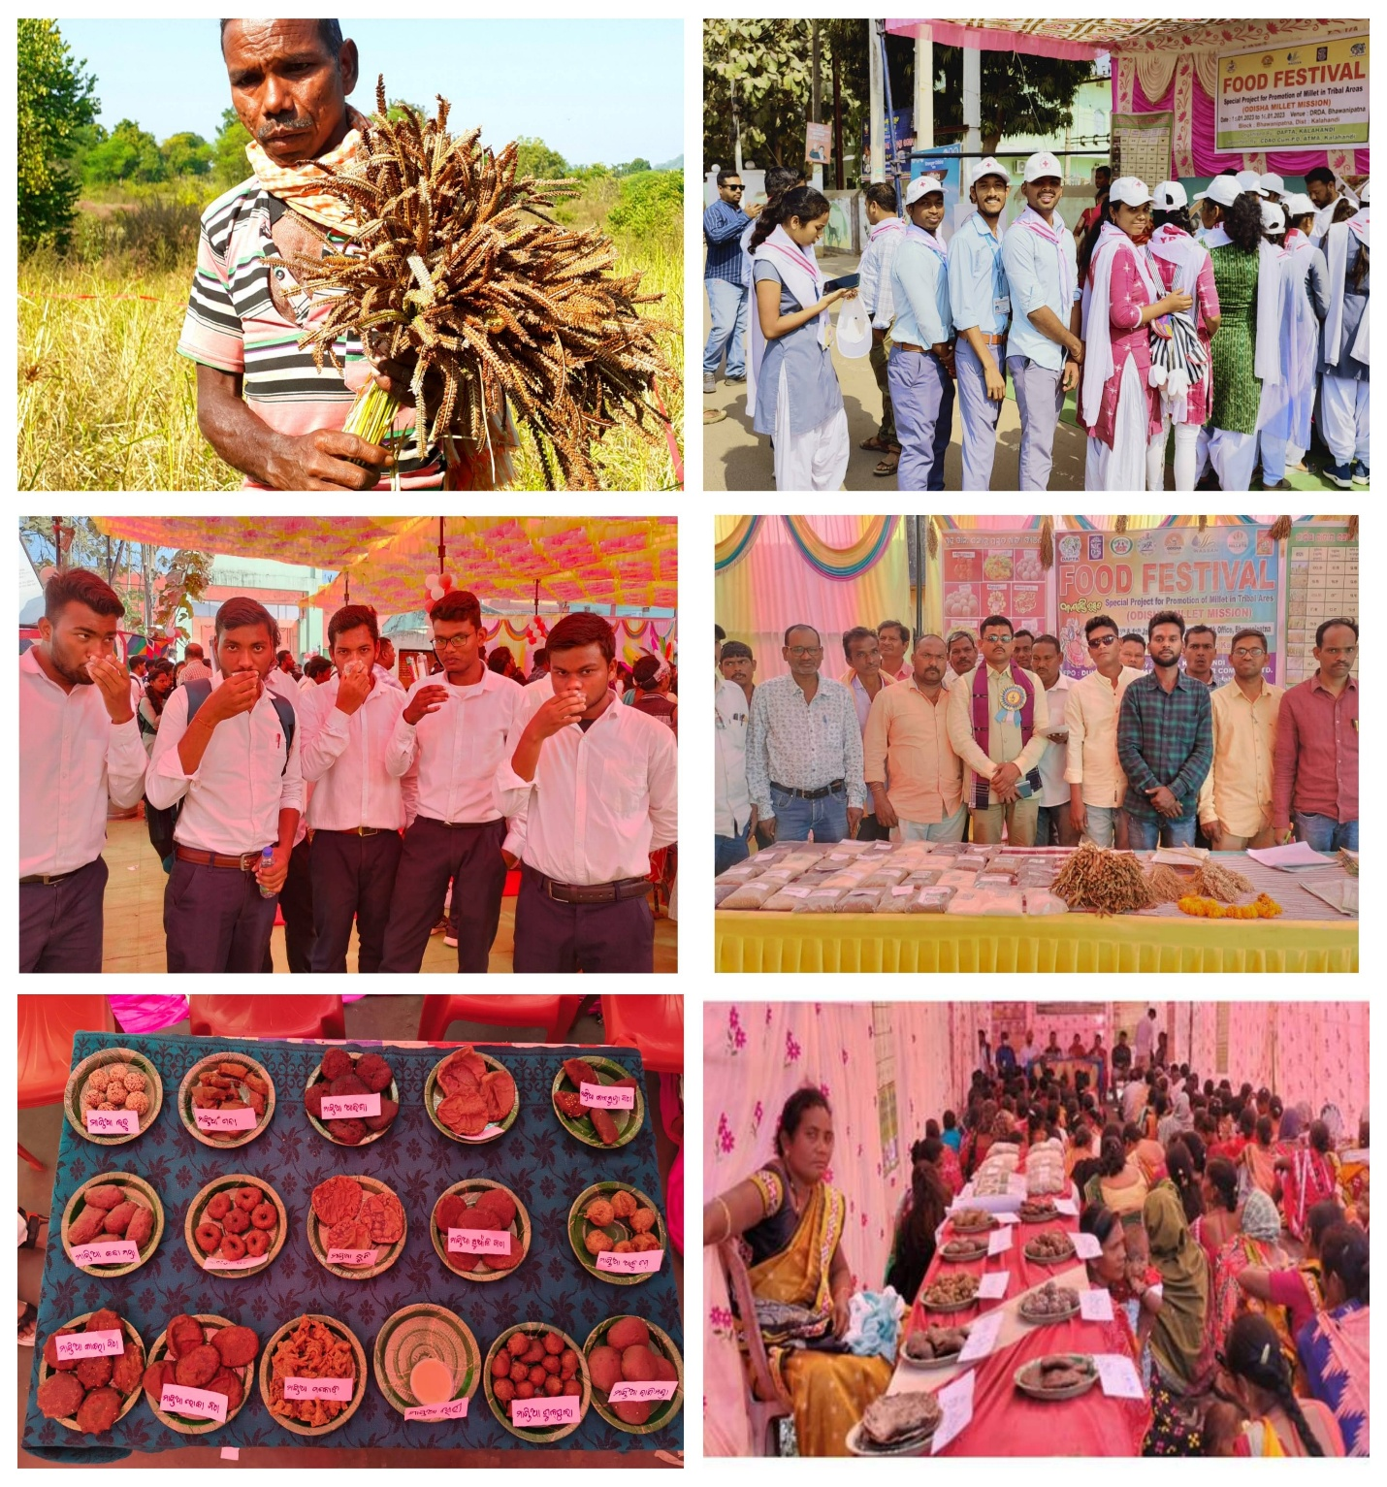

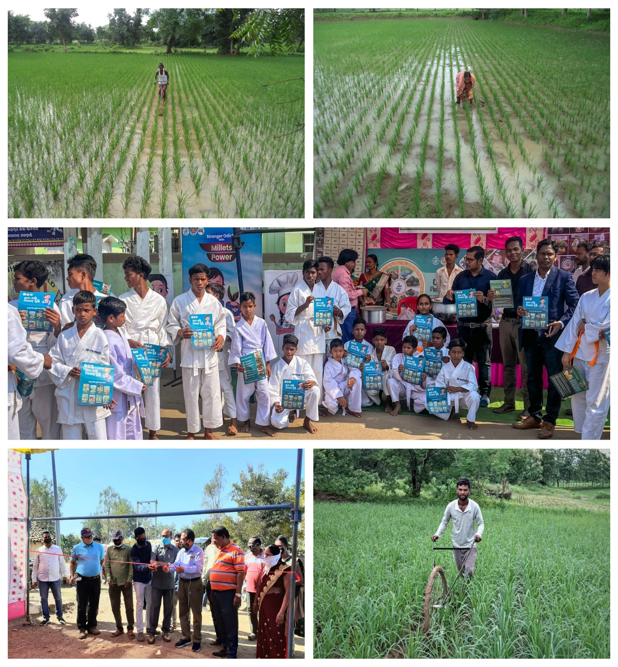

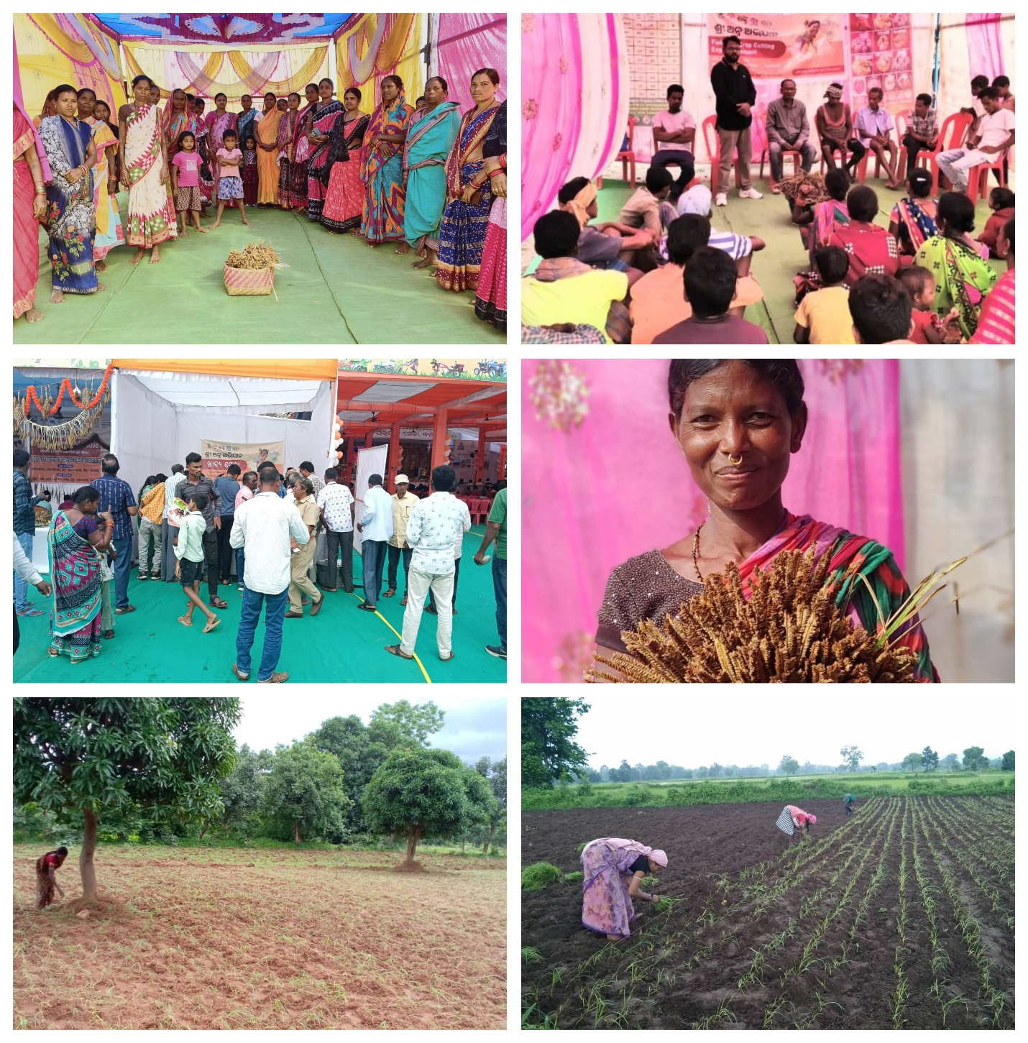
TARGET INTERVENTION (TI), Supported by Odisha State Aids Control Society (OSACS)

DAPTA, with the support from Odisha State AIDS Control Society (OSACS) has implemented the targeted intervention project in Bhawanipatna, Lanjigarh, Junagarh and Jayapatna Block of Kalahandi district. In the year 2024-25, DAPTA have covered 477 beneficiaries, out of them 271 are MSM & 206 are TG.
- Project Objective: -
- Prevention infections through saturation of coverage of high-risk group with Targeted Intervention scaled up intervention in a general population.
- Provide greater Care, Support & Treatment to larger number of PLHAs (60%).
- Strengthen the infrastructure system 7 human resources in Prevention, Care & Support programs at District, state and National level.
- Increasing awareness and knowledge about HIV/AIDS, ways of transmission, and ways of preventing transmission among the selected groups.
- Increasing knowledge about CONDOM and its use by the target groups. Increase knowledge about the signs and symptoms of STIs and increase appropriate treatment seeking for STIs.
- Make the environment more conducive for carrying out HIV/AIDS related awareness and promotional activities, through appropriate advocacy.

Sl. No. | Activity | Target | Achievement | Percentage
1 | One to One Contact | 5724 | 4935 | 86%
2 | Regular Contact | 5724 | 4519 | 79%
3 | Condom Demand VS. Distribution | 119862 | 68712 | 57.32%
4 | No. of HRGs counseled | 1908 | 2117 | 111%
5 | No. of HRGs refer to ICTC | 954 | 883 | 93%
6 | No. of HRGs tested at ICTC | 954 | 831 | 87%
7 | No. of HRGs tested at Network Clinic | 1908 | 1655 | 87%
8 | Regular Medical Check up | 1908 | 1535 | 80%
9 | STI ` | NA | 86
10 | Presumptive Treatment | 88 | 54 | 61.36%
11 | No. of HRGs tested at RNTCP | 477 | 228 | 48%

Activities | Outputs
Demand Generation Activity | We have organized 60 no. of Demand generation meeting at our different hotspot. The objective behind the activity is to increase HIV/TB testing, protective sex. We also discussed on signs and symptoms of HIV/AIDS, STI/STD, uses and benefit of ART medicine & safe behavioral practices. During the year we covered 450 key populations through the hotspot meetings. 110 no of new HRG (key population) identified during the meetings.
Health Camp | We conducted 2 nos. of Health camp at Bhawanipatna and Jayapatna operational area. In this camp we covered 105 nos. of HRGs and checked up their health status by a doctor and provide medicine as per their disease. We also organized a small awareness meeting on their personal hygiene, healthy life and advise them on HIV/AIDS, STD/STI and safe sex.
World AIDS Day | On the eve of World AIDS day, we the DAPTA TI observed World AIDS Day week from 25/11/2024 to 1/12/2024 at the different hotspot of our operational area with our HRGs. During these days we spread the awareness end the stigma near of the HRGs and others. Through various events, small group meetings and one to one contact our PE, ORWs were trying to aware the people on HIV/AIDS & spread the message of global solidarity shared responsibility.
Advocacy Meeting | This year we conducted 4 nos. of Advocacy Meeting with different service providers of our project area. Objective of this meeting was to initiate the HIV testing of Key Population, linkage them to social scheme and give social justice in their day today life. It was decided to have proper coordination and mutual understanding with all service providers.
Community Event | On 22 to 25th February 2024 TI Project DAPTA organized a community event for creating awareness among the Key population at Jaipatna Site. In this occasion we organized a small group meeting where we gave brief knowledge on various topics.  - Why TI project is working for MSM/TG community.  - Component of TI.  - About HIV/AIDS  - About PLHIV & their treatment  - Condom Promotion  - Social security scheme

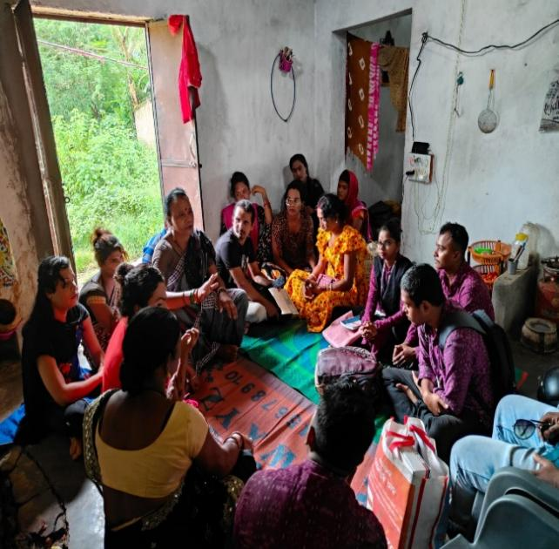  Demand Generation Meeting | 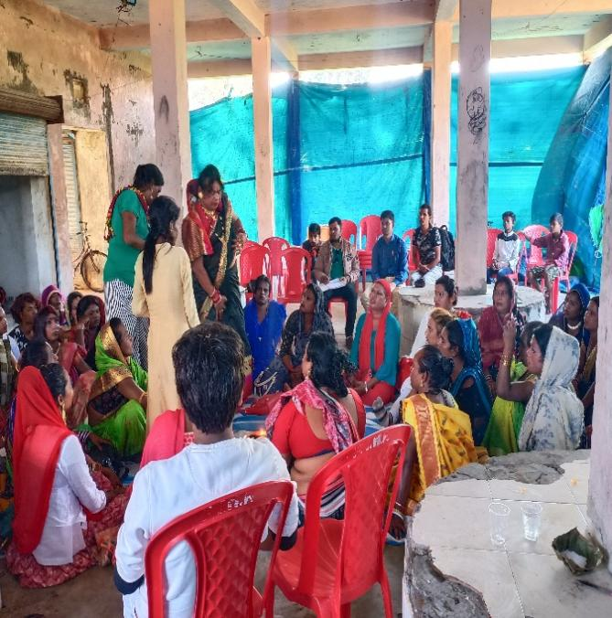  Celebration of World AIDS day
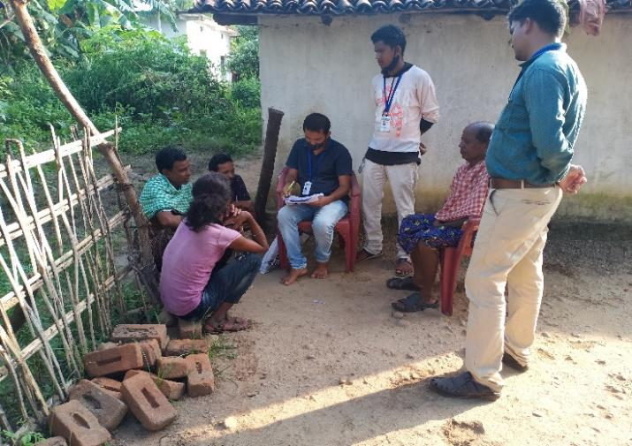  Relief Distribution | 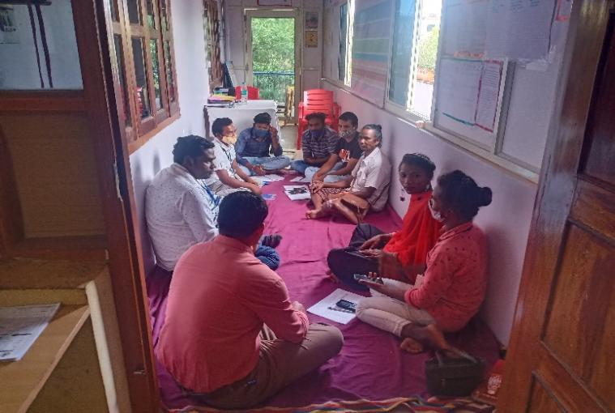  Staff Review Meeting
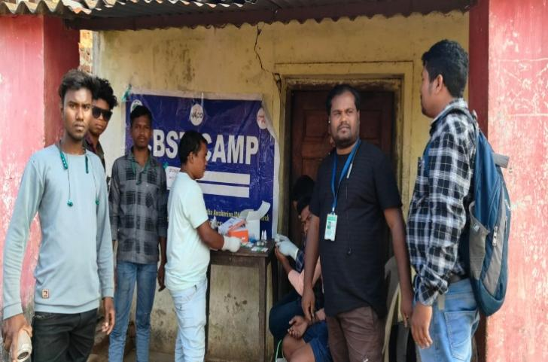  Health Camp | 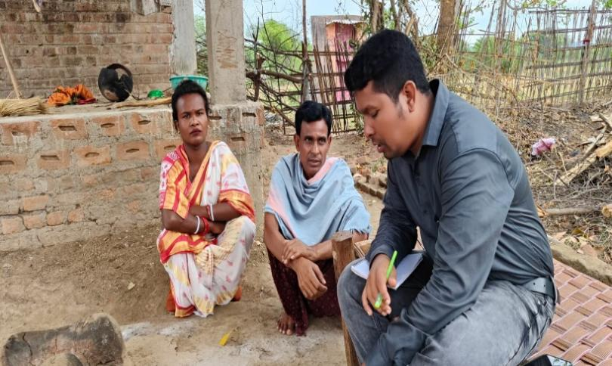  Field Visit
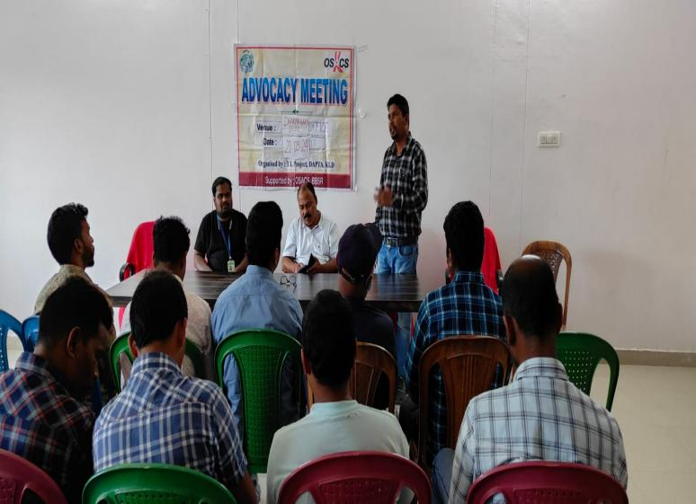  Advocacy Meeting | 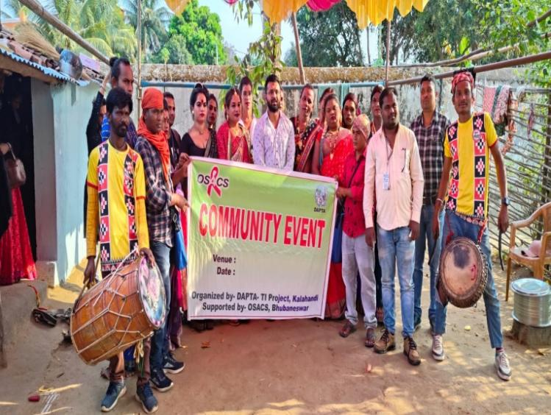  Community Event

Ensuring food and livelihood security of indigenous and other marginalized communities
Supported by MCC

Project Title: Ensuring food & livelihood security of indigenous and other marginalized communities in Thakurmunda Block, Mayurbhanj, Odisha.
Project Location
The project is implemented in 7 villages of Thakurmunda Block, Mayurbhanj district, Odisha:
- Guhaldihi
- Kisunsahi
- Gadasahi
- Mukundiapada
- Bapalsahi
- Baunsadiha
- Maniksahi

Partner Organization Name: Development Agency for Poor & Tribal Awakening (DAPTA)
- Outcome 1: Local communities have knowledge and practice on improved farming techniques and engaged in effective natural resource management.
Activities Implemented
- Activity 1.2 - Village meetings: Village meetings and VDC members meetings in all 7 project located villages were conducted by DAPTA staff during this reporting period. The targeted communities were oriented on the MCC supported project on food security and livelihoods. The other discussions initiated during the Village meetings were information dissemination on various Government development schemes, programmes, entitlements and benefits and strengthening of VDCs (Village Development Committees), strengthening of SHGs and Liaisioning with Government offices as like Lift Irrigation, Horticulture, ITDA, MGNREGS, Agriculture department etc. Meetings at village level were facilitated to understand the specific problems faced by local communities and how to address them with Government and other stakeholders. Criteria for selection of beneficiaries for Government schemes and programmes, etc., were undertaken.
- Details of Village meetings
Village | No. of HHs
1. Kisunsahi; 6 village meetings with VDC members were organized and 1 SHG meeting was conducted, in which meeting 3 SHG group members were attendant. | 49
2. Baunsadiha; 6 village meetings with VDC members, were organized in village level according to the agenda. 1 SHG meeting was organized, Liaisioning with Government offices, meeting was conducted once in this reporting period. | 71
3. Bapalsahi 6 village meetings with VDC members were organized. 4 SHG meeting was organized, Liaisioning with Government offices, meeting was conducted once in this reporting period. | 84
4. Maniksahi 6 village meetings with VDC members were organized. 2 SHG meeting were organized, Liaisioning with Government offices, meeting was conducted once in this reporting. | 46
5. Mukundiapada 6 village meetings with VDC members were organized. 2 SHG meeting was organized 2 times, Liaisioning with Government for lift irrigation and deep bore well, meeting was conducted once in this reporting period | 60
6. Gadasahi 6 village meetings with VDC members were organized. SHG meeting was organized once and Liaisioning with Government offices for lift irrigation and deep bore well meeting was conducted once in this reporting period. | 66
7. Guhaldihi 6 village meetings with VDC members were organized. 1 SHG meeting was organized and Liaisioning with Government offices for lift irrigation and deep bore well, meeting was conducted once in this reporting period. | 70
- Outcome 2* Increased sustainable income of local communities/CBOs.
Activity 2.1 Training to the CBO’s (SHG):

This training was conducted 2 times by DAPTA on date – 18/12/2024 and on date - 22/02/2025. Total numbers of participants attended – 65, Male - 00, Female - 65, Venue DAPTA Office, Thakurmunda, Resource Persons - Two times by - Mr. Ramani Ranjan Ojha BPM (Block Project manager).

- Activity 2.2 Trainings on Alternate Livelihood Options: Poultry & Goat Rearing.
This training was conducted by the DAPTA team member on date – 24/02/2025. Total numbers of participants 32. Male - 22, Female - 10, Venue DAPTA Office, Thakurmunda, Resource Person: Dr. Priti Prasanna Sahoo Assistant Veterinary Surgeon (A.V.S.) Thakurmunda. This training was conducted once this reporting period.
- Activity 2.3 Training on primary treatments and Vaccination for the domestic animals.
This training was conducted by the DAPTA team member on date – 09/01/2025. Total number of participants 21. Male - 14, Female - 07, Venue DAPTA Office, Thakurmunda, Resource Person: Dr. Priti Prasanna Sahoo A.V.S. (Assistant Veterinary Surgeon) Thakurmunda. This training was conducted once this reporting period.
- Activity 2.4 One day Training on Pisciculture:
This training was conducted by the DAPTA team member on date – 13/12/2024. Total number of participants 35. Male - 18, Female - 17, Venue DAPTA Office, Thakurmunda, Resource Person: Mr. Dillip Kumar Jena, JFTA (Junior Fisheries Technical Assistant) Thakurmunda. This training was conducted once in this reporting period.

The major topics covered: - Fish cultivation is a most profitable business for the beneficiaries who have dug their own ponds by themselves or those who were benefited by the Govt. scheme. The Govt. approved ponds were also dug through MGNREGS scheme by which the beneficiaries contribute their labor and get wages for it. It is also a both dual side benefit for the beneficiaries.
- Activity 2.5 Training on Nutritional Kitchen Garden and commercial vegetable garden.

This training was conducted by the DAPTA team member on date – 11/11/2024 and 9/12/2024. Total numbers of participants - 66. Male - 48, Female - 18, Venue DAPTA Office, Thakurmunda, Resource Person: Mr. Umakanta Singh APC (Assistant Project Coordinator) and Village Mobilizer Mr. Sauna Hembram. In the second training programme resource person was, Village Mobilizer - late Mr. Singray Purty and Village Mobilizer - Miss Namita Mohanta DAPTA, Thakurmunda. This training was conducted 2 times in this reporting period.

Outcome 3: #of HHs benefitted with Government programmes: MGNREGS; ii) Social welfare programmes; iii) Fishery; iv) Other petty Business
DAPTA has established the initial contacts with various Government line departments like Agriculture (AAO), Animal Husbandry) (Veterinary Surgeon), Horticulture, Fishery (AFO), Block Development Officer (BDO), Mission Shakti/OLM (Block Program Manager), ICDS (Child Development Project Officer - CDPO, Anganwadi workers), Accredited Social Health Activist (ASHA) and Auxiliary Nurse and Midwife (ANM), GRS (Goan Rozgar Sathee under MGNREGS). The project Coordinator and staff have interacted with the nodal Government authorities from the various Government line departments at Block level.
DAPTA has facilitated the process of awareness generation and accessing social security and safety schemes like Old Age Pensions, Public Distribution System (subsidized rice), ICDS, MDM, Subhadra scheme for women to promote rural livelihoods. There have been awareness drives and campaigns in all operational villages on the Government development schemes and benefits. Deserving beneficiaries have been linked with the Government schemes and benefits. DAPTA has also established working relationships with PRI members like Sarpanch, Ward Members, etc.
Case study of a Farmer – Whose life had gone through a very poor, tottering and tear full condition
The story was collected by Mr. Umakanta Singh, Asst. Project coordinator DAPTA
On date – 15/03/2025
Mr. Suresh Purty 36 years, wife Mrs. Arati Purty- 32 years village – Baphalsahi, G.P- Jarak, Block- Thakurmunda, District- Mayurbhanj, Odisha. He belongs to BPL (Below Poverty Line) category. He is having 1 son - Mr. Solomon Purty-8 years. His parents are alive and they get old age pension from Government of Odisha. The family is of 05 members in his family including him.
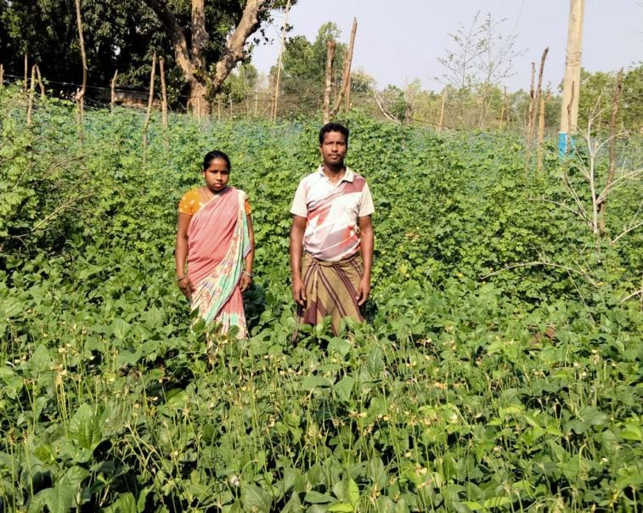
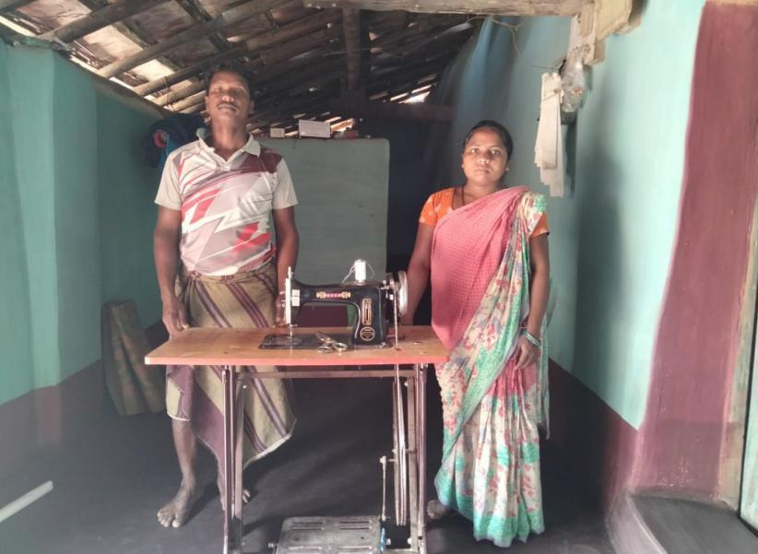

Before implementation of the project, Mr. Suresh Purty was doing farming paddy crop once in a year during the Kharif season (monsoons). He was cultivating vegetables in a small patch of his land. H has 4 acres of land. But he is farming only in 1 & half acre of land she is doing paddy farming and some vegetable farming in his backyard. The remaining land was unused for her because those lands are uplands. He always depends on rain water for his cultivation. She faced lots of problem in doing cultivation because of erratic rainfall. From that, he used to get 5 to 6 quintals of paddy annually in traditional farming process. (Which Total cost was Rs. 10,800/-). After finishing of paddy farming, she does local/casual labour work in nearby villages, MGNREGS work in his own village. These works are not sufficient earning source, for Suresh. VDC members and the DAPTA team decided to support him a Sewing machine to start a petty business, as there were no other alternative earning options for Suresh Purty. He and his family were always going through a tottering condition at that time. He became hopeless. But whenever DAPTA MCC FSSL project was implemented in his village Bapalsahi, Suresh took interest to know about the project aims and objectives. He regularly attended the village meetings and thematic trainings. By the good efforts of DAPTA team members, the lift irrigation department surveyed 50 acres of land at village Bapalsahi and the officers decided to install a River Lift Irrigation point at the bank of river Salandi. The SHG group members of village Bapalsahi were always encouraged by DAPTA team members to support any agency, which was interested to install a Solar Irrigation point at another site of the river bank, near by the village. After installation of both irrigation points, the uplands of Suresh Purty became irrigated. Suresh is very laborious so he started different kinds of vegetable farming during all seasons.
He attended the trainings like Natural Resource Management, Kitchen Garden, Commercial vegetable farming, Improved Agriculture Method etc. Whatever questions he had, he got satisfactory answers from the Resource Persons. He did use organic (compost manure). He has preserved last year vegetable seeds which he got from DAPTA and added some seeds buying from the market. He invested of his own Rs. 6000/- in buying desi varieties like cauliflower, Brinjal, beans, rat tail beans and bitter gourd. In taking care of the crops, labour work was done by himself and by his family members. He got all the valuable information about agriculture, knowledge and scientific technique from the Village Mobilizer of DAPTA - Mr. Sauna Hembram and Rev. Umakanta Singh. They counselled and encouraged him to prepare of the sapling bed, its distance between seeds, and planting of the saplings in a line, in systematic way. He used organic manure and organic pesticide (compost, cow urine, cattle dung) in it to control harmful insects, infesting his crops. He uses the Yellow Card in his crop field. He has also fixed T shaped wooden birds sitting stands.
He could earn Rs. 32,000/- from paddy production, Rs.5000/- by selling of 1 quintal brinjal (per kgs @ 50/-), Rs. 5000/- by selling 70 kgs cauliflower @ 60/- Rs. 4200/-, Rs.1400/- by selling of rat tail beans and standing tree beans within 5 months and Rs. 4000/- from Tailoring.
Lesson learnt from: - Through education, developing self, hard labour and focus/concentration life can be made easy, well developed and comfortable.

Promoting Women’s Organizations to Combat Domestic Violence and Anit-Trafficking
Supported by Swiss Women’s League (SWL)

Aim:
Empower women and girls to combat Domestic violence, Trafficking and Protection of Girl Child in Kalahandi district of Odisha
Specific objectives:
- To support community-led collective actions to ensure focused attention in dealing with offences of domestic violence and human trafficking.
- To ensure victim-centric approach which takes into account the best interest of the victim/survivor and prevents secondary victimization/re-victimization' of the victim.
- To ensure a gender sensitive and child rights sensitive approach in dealing with the victims of domestic violence and Trafficking.
- To facilitate inter-departmental collaboration among the Police and all other Government agencies and Departments such as CHILDLINE, DCPU, Child Welfare Committee, Women & Child, Labour, Health and the civil society.
Target Groups:
The targeted beneficiaries include women, adolescent girls, men from the most marginalized Tribal, Dalit and Other Backward Classes and other most vulnerable communities, Panchayati Raj Institutions (PRI) members (Local Self Governance bodies) and other relevant duty bearers in Kalahandi district, Odisha.
Geographical Coverage:
Direct project interventions in 3 Gram Panchayats Namely Kamthana, Karlaguda and Palsijharan in Bhawanipatna Block of Kalahandi district, Odisha. The indirect coverage will be the entire district of Kalahandi.
Vocational Tailoring Center:
We have a Vocational Tailoring Center (Tailoring) at Ghusurigudi of Palsijharan GP of Bhawanipatna Sadar block. 78 women and Adolescents girls have completed tailoring training. Some of them produced petticoats and sold them in the local market and earned.
Other Activities:
- 3 nos. of child marriage cases prevented with the help of District child protection unit, Child welfare committee, police and ICDS. The ICDS department has instructed all the ICDS workers for the registration of migrants and to create awareness about the prohibition of child marriage.
- 12 no of orphan and single parent children identified and produced before the Child welfare committee for support and rehabilitation out of which 2 children are staying in the govt. shelter continuing their education, another 2 children will be get sponsorship from the CWC@Rs 4000/ month and the rest 8 children will be admitted in the govt. run boarding school in the coming session.
- 18 no of Domestic violence cases addressed with active support and co-operation District Legal Services Authority and Family counseling Centre- 16 cases mutually solved and 2 cases are in the family court and they have received legal aid support free of cost.
- 2 nos. of HIV positive patients got access for Madhu Babu pension, a state government social security scheme for the HIV people.
- 43 widow women applied for the benefit under National family benefit scheme after the death of their husbands.
- Out of 85 passed out girls and women from the mobile tailoring unit in 2023, 27 have purchased their own sewing machine and now they are self-employed.
- 93 women and girls are receiving tailoring training during the reporting period i.e. 2024.
- The District Education Officer assured to upgrade the primary school (1st to 5th std) of Kholandi village to upper primary school (1st to 8th std) following to a memorandum submitted by the women and girls forum of Palsijharan Gram Panchayat. At present the upper primary school for Kholandi village is in a distance of 10km. Because of hilly terran parents are scared to send their children to such a distance in fear of wild animals. Therefore, the GP level women forum came forward and had given a memorandum regarding the up-gradation of Kholandi primary school. The villagers and women forum are very much happy to see their effort bearing fruit.

Sl. no | Program | Place | No of  program | Participants | Date
1 | Staff Training Program | DAPTA Conference Hall | 1 | 07 | 26/2/2024 to 28/2/2024
2 | Campaign of girl’s education, Save girl child, Child marriage and protection of girl child. | Ghusurigudi | 1 | 110 | 6/3/2024
3 | Thematic Training of women group on DV Act, ITPA | Bhawanipatna | 1 | 30 | 31/5/2024 to 1/6/2024
4 | Training of Adolescent Girls group on leadership, Life skill education, Menstrual hygiene and HIV | DAPTA conference hall | 1 | 30 | 3/4/2024 to 5/4/2024
5 | Formation and strengthening of 3 GP wise women forum | Kamthana, Palsijharan and Karlaguda | 3 | 94 | 21/10/2024,  26/10/204 & 9/11/2024
6 | Formation and strengthening of 3 GP wise Adolescent girls forum | Kamthana, Palsijharan and Karlaguda | 3 | 98 | 18/9/2024,  21/9/2024 & 28/9/2024
7 | Liaisioning and networking with PRIs, GOVT authorities, CSO & NGO | Kamthana GP, Karlaguda GP and Palsijharan GP | 4 | 113 | 13/3/2024,  28/3/2024, 16/7/2024 & 15/8/2024
8 | Campaign on Domestic Violence and Anti trafficking | Bhawanipatna | 1 | 63 | 3/12/2024
9 | Sensitization Program on Child marriage and Trafficking | Karlaguda High school | 1 | 36 | 24/7/2024
10 | Awareness meeting with Women Groups | Karlaguda GP, Kamthana GP and Palsijharan GP (20 Villages) | 220 | Each meeting has 15 to 30 members participated | January 2024 to December 2024
11 | Awareness Meeting with Girls Group. | Karlaguda GP, Kamthana GP and Palsijharan GP (20 Villages) | 220 | Each meeting has 15 to 30 members participated | January 2024 to December 2024

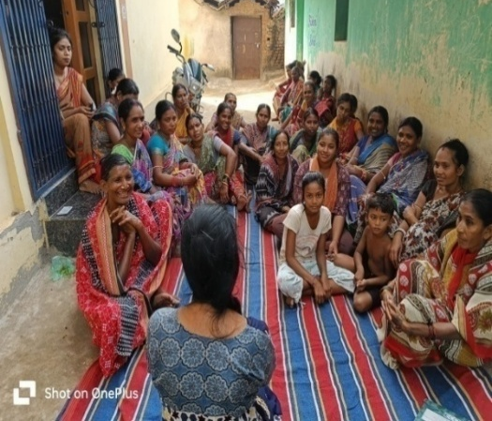
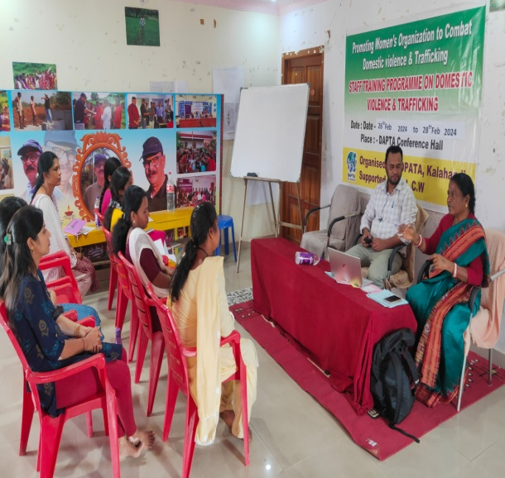
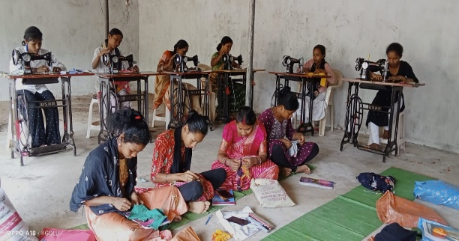
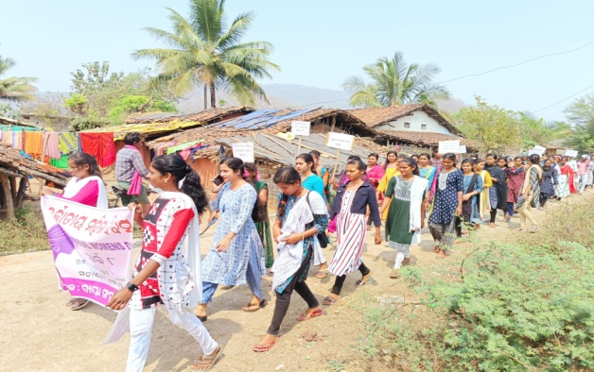
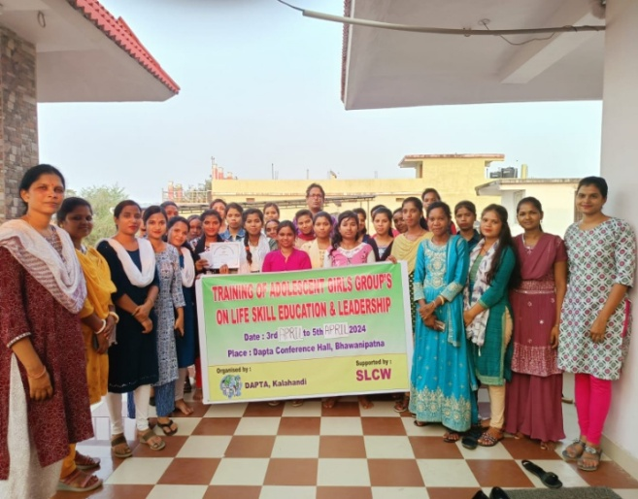
Photo Gallery:
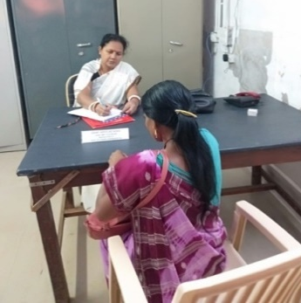
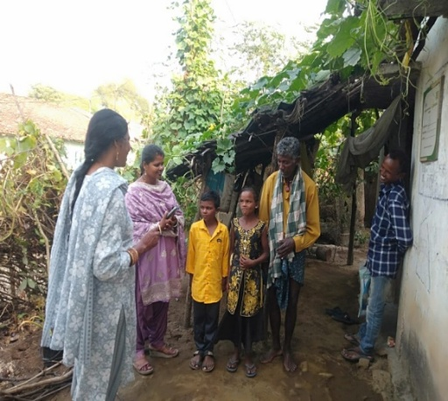
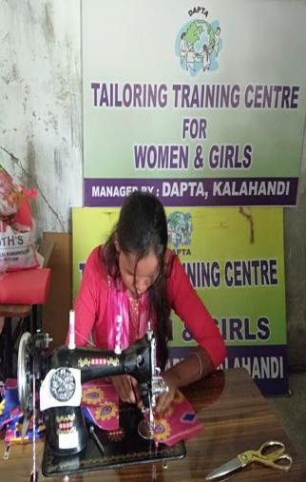
FCC (Family counseling center)
Supported by Central Social Welfare Board
Covers Kalahandi District

Objectives
- To provide Preventive, Promotive, and Rehabilitate services to women and children who are victims of atrocities and exploitation through Counseling.
- To create awareness about the existing laws related to women and children and provide facilities like free legal Aid, referrals to short stay home, Medical.
- To provide Services to Women and Children in distress through Crises interventions, investigation of disharmony, alcoholism and illness.
- To enable reconciliation and amicable settlements out of court.
Activities
Services for women with problem Like-
- Harassment and wife battering
- Exploitation
- Dowry
- Marital disharmony
- Family problem
- Mental illness
- Alcoholism
- Legal aid
- Other Psycho Social problem
Services Provide
- Counseling
- Organizing Awareness Programs in School and Communities.
The purpose of counseling is to help individuals or groups address and resolve personal, social, or psychological difficulties. Counseling provides a supportive and confidential environment where people can talk about their concerns, feelings, and experiences with a trained professional who can help them explore their thoughts and emotions, gain new insights and perspectives, and develop strategies for coping with challenges and achieving their goals. Counseling can help people deal with a wide range of issues, including stress, anxiety, depression, relationship problems, grief and loss, trauma, addiction, and career or educational challenges. The goal of counseling is to empower individuals to make positive changes in their lives, improve their overall well-being, and achieve greater self-awareness and personal growth

Social Welfare Board
Yearly progress report 2024-25
1st April 2024 to 31st March 2025
Name of the organization: Development Agency for Poor & Tribal Awakening (DAPTA), Kalahandi, Odisha
Sl no | Types of Cases | No of Cases Registered | No of Cases solved | No of Cases pending | No of beneficiaries
1 | Dowry | 13 | 5 | 8 | 13
2 | Domestic Violence | 20 | 12 | 8 | 20
3 | Alcoholism/ Drug addiction | 27 | 18 | 9 | 27
4 | Marital Maladjustment Spouse & In-laws | 2 | 0 | 2 | 2
5 | Economic Crises | 6 | 2 | 4 | 6
6 | Family & Property Dispute | 9 | 2 | 7 | 9
7 | Extra Marital Affairs | 14 | 9 | 5 | 14
8 | Personality Difference | 4 | 3 | 1 | 4
9 | Mental & Physical Torture | 17 | 12 | 5 | 17
10 | Depression | 0 | 0 | 0 | 0
11 | Human Trafficking | 0 | 0 | 0 | 0
12 | Harassment | 0 | 0 | 0 | 0
13 | Cyber Crime | 0 | 0 | 0 | 0
14 | Any other  1-Parents Interference  2-Parents Negligence  3- Gambling  4-Cheating | 4  2  3  7 | 2  0  0  0 | 2  2  3  7 | 4  2  3  7
Total |  | 128 | 65 | 63 | 128
No of Awareness Camps/ Mahila Meeting Conducted –29
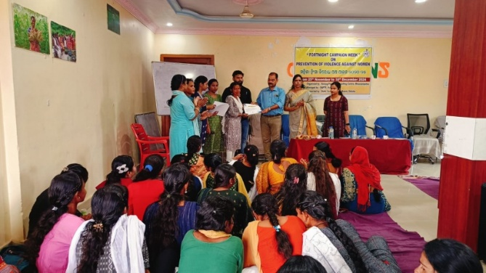
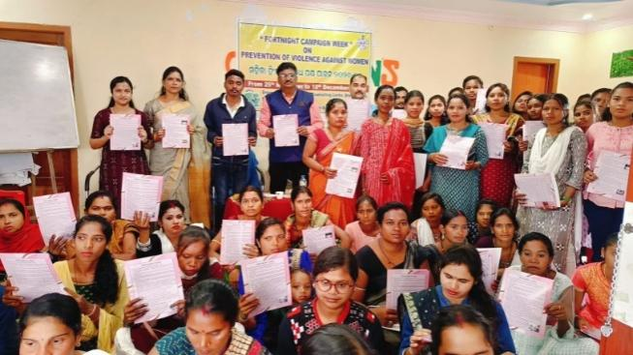
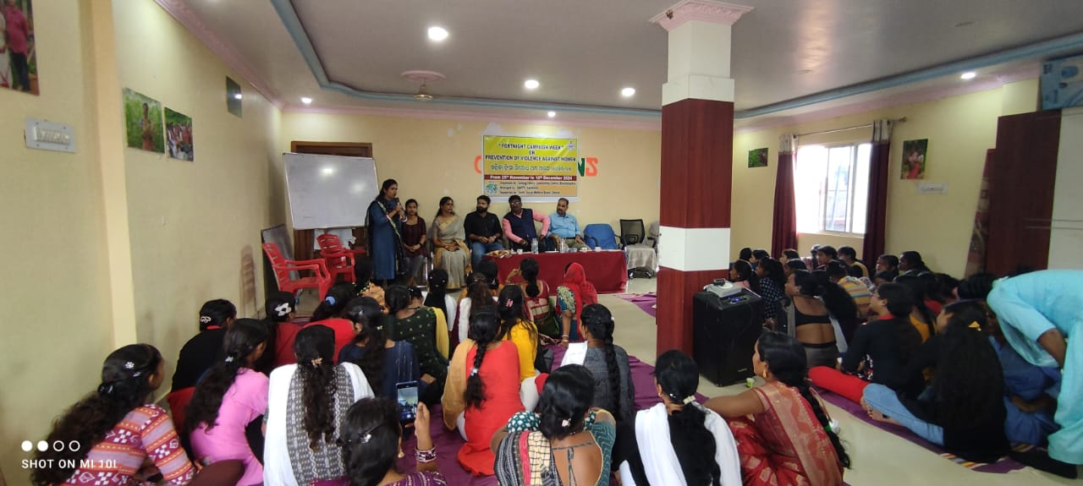
No of Sub- Committee Meeting Conducted- 4
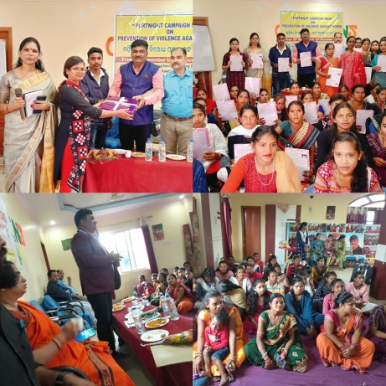
SEWOH_EXIT PROJECT
Supported by Terre Des Hommes (TDH), Germany (BMZ)

We have formed village level farmers committees, women committees, youth committees, children committees and Forest Rights Committees. The committee members are being continuously trained and capacitated on different thematic aspects of livelihood.
- The existing 19 eco-clubs convened for 212 times (1745 boys, 1560 girls- Total 3305nos of students) and 35 children groups convened for 425 times (2647 boys, 2236 girls – total 4883 students) discussing various issues such as environment degradation, pollution, rights of children, seed ball preparation and throwing etc. apart from celebrating/ observing special days of thematic day, campaigns, cleanliness drive in schools etc.
- One Training on health and hygiene practices was planned and organized where 30 boys and 20 girls from 19 eco clubs participated
- 182 village level health & hygiene campaign organized during the reporting period and a total of 1382 (669M, 713 F) children and youths took part in different programs, group discussion and rallies held on the occasion. The participants reached all households and diffused the key messages in the community.
- 33youth groups are there with 588 members (Male 354 and Female 234) in 33 villages and 395 such sittings held with total attendance of 5563 youths (3146M, 2417F).
- A two-day district level meeting organizes with 50 youths to strengthening of networking with government, NGO and to provide a platform advocate their ecological rights- Done in the month of July with 55 (41M, 14F) youth representatives
- 25 agricultural groups exist in the project villages with 524 membership (212 M, 312 F)
- Field demonstration of raised bed for sowing of turmeric rhizomes, raised bed nursery, preparation of beds for sowing of different crops, seed treatment etc. was done. 6 villages were provided with Shade net houses for raising nursery, taking different short duration crops like greens, radish, coriander etc. after nursery was over and growing of mushroom in off season on group basis. As such CRPs and CMs jointly provided hand holding support to 1500 farmers (635 M, 865 F) in 50 villages.
- Leadership Trainings – 25 participants X 3 trainings. 77 participants imparted training in three batches (Male - 5nos, Female – 72nos)
- 25 seed banks established and strengthened
- 1000 households/ farmers are targeted this year covering kharif and Rabi season. As of now 1100 farmers were provided with seeds sufficient enough for 2 cents of land.
- Organic Fertilizer Accomplished in 1st and 2nd year of the project.
- Training of 200 farmers by the CRPs. 8 nos of trainings at village level covering 210 farmers (Male-81nos, Female- 129 nos)
- 240 farmers trained on mushroom cultivation (paddy straw, oyster). 40 participants back log in 2023 and 200 farmers in 2024. The training program was organized in phases and duration was for 3days (2-day classroom teaching, 1 day practical and demonstration in field). 30 moulded drums given in 30 villages to soak the straw.
- Training was given to 125 women on seeds, importance of seed, what are qualities of seed, collection, segregation of seeds, process of seed preservation etc..
- A one-day seed fair programme was organized at mango groove of Kandhasarli village where 112 farmers (34 M, 78 F) farmers attended the festival. This was also attended by officials from horticulture, Kutia Kandha Development Agency, Chairman- The Kalahandi Development Council, Dharani Rural Development of Rayagada, Documentation officer, State Coordinator of Lake Garden besides others
- The block level food festival was organized in the month of March 24 at Salapkana village where 119 farmers and women from different villages took part. Officials from Living Farm, KKDA Lanjigarh, Lake Garden, Documentation Officer etc. took part
- The district level food festival was organized in the month of December 24 at Bhawanipatna where 100 farmers and women from different villages took part. Additional District Magistrate (ADM), Kalahandi inaugurated the event. Deputy Director Horticulture, District information and public relation officer, Microplanning and livelihood expert, District FRA cell coordinator, Lanjigarh FRA cell coordinator were the other dignitaries invited.
- Completed in fifty villages. The plans were prepared with active participation of CRPs and support of fellow farmers and proper guidance of community mobilizers. It was completed for 1646 HHs.
- 3 defective water structures one each at Phuldumer, Kaksur and Ejurupa
- 19 women groups with 228 members have been formed. Total of 230meetings were organized by these groups during this period.
- A training programme of the Women Farmer Producers’ group where 40 women of different villages took part and it was conducted in the month of April 24 and Dec 24. The producer group member underwent a one- day training capacity building on operation of siali leaf plate making at Ejurupa unit.
- Planned for 50 participants in two phases and 50 participants took part in the training programme.
- Training on government food security and agriculture programme Accomplished in the first and second year of the project.
- 50 numbers of banner enlisting important schemes of government on food and social security had been placed at important places of the villages and discussions were held with the villagers in different meetings and groups. Also, awareness of information on nutrigarden calendar, importance 1000 days, role of jaanch committees, Angan Wadi Center etc. on wall present at a prominent place of the villages.
- A training programme was conducted for our project staff on Participatory Learning and Action (PLA). After the training and by providing active and hand holding support to community mobilizers, PLA meetings were carried out in the community to keep a track of the nutrition and growth monitoring. To stream line the activity further, another training programme by an external resource person was done in the month of July 2024.180 meetings have been conducted with 4104 participants. (882 M, 3222F)
- 7 health camps were organized in7 places of 5 GPs where 352 (148M, 304F) vulnerable patients were diagnosed and treated for various diseases and sufferings.
- 21 Anganwadi Workers were trained on role and responsibility, how to increase the outreach of ICDS programme, coordinating with DAPTA organization in executing the duties and responsibilities etc.
- Training of trained village birth attendants Plan was to train 50 village birth attendants and training was given to 50 birth attendants.
- Strengthening of VHSNCs-: 40 participants were imparted training as per the plan.
- Training of women and adolescent girls on health, nutrition and WASH-100 (F) were trained in 4 batches at 4 locations
- Planned and completed for 100 boys and 100 girls in different high schools of the area by resource persons. The programme was conducted in 5 high schools.
- The dependenscy of the community on forest resources for livelihood is indispensable. So, title and ownership of land is becoming crucial for their life and livelihood. It is becoming more important in the context of Mo Jungle Jami Yojana launched by Government of Odisha which gives guarantee to the eligible individuals and community of their rights and usage over jungle and title. The workshop was conducted in the month of September 2024 with 60 participants.
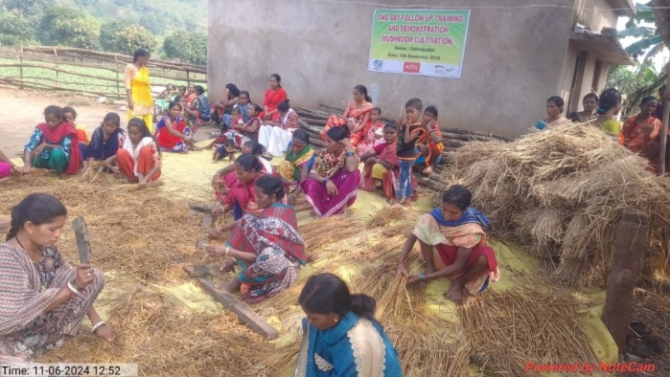
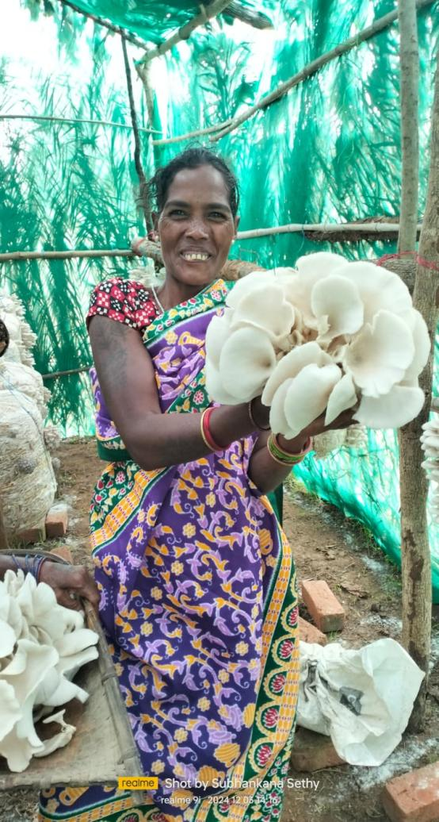
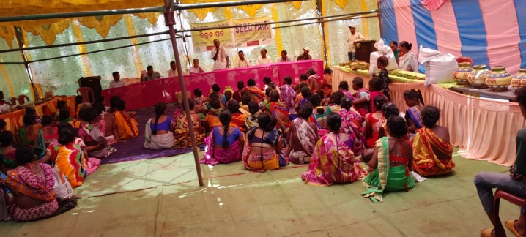
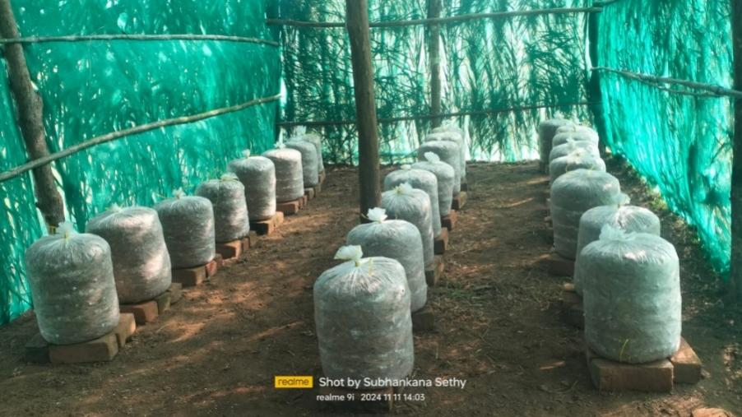
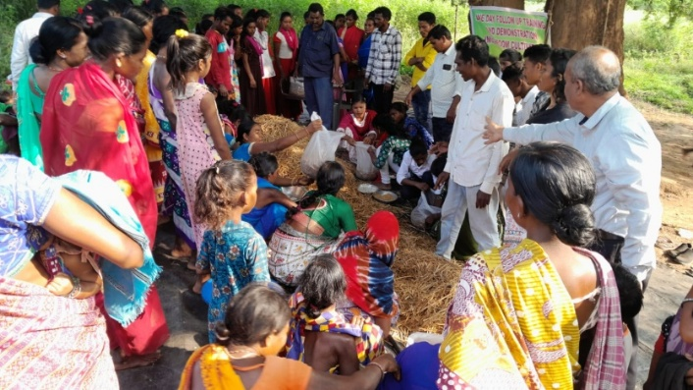
Quality Primary Education for Tribal Children in Remote Village
Supported by Smile Foundation

KEY HIGHLIGHTS OF THE PROJECT (2024-2025)
- The Average attendance of children and teachers were 75% and 90% respectively.
- Total 300 Curriculum days conducted during the reporting period
- Republic day, saraswati puja Puja, Ganesh Puja, Children’s Day, Diwali and Value education program on Respect, Cleanliness drive were conducted.
The Mission Education program was implemented in a holistic way wherein, our program fill the gap what left in School, through our program we not only giving education but we help them to improve in sports, dance, co-curricular and extra-curricular activities like Drawing class and Dance class was organized to ensure the overall growth and development of the children. In the period from April 2024 to March 2025, the following major activities were organized at the ME center of Kanarla, Dahanipadar and Sorpadar.
Class/Gender break up of supported Beneficiaries
Class | No. of Girl student | No. of Boys Student
1st | 13 | 14
2nd | 4 | 12
3rd | 12 | 10
4th | 6 | 10
5th | 7 | 9
6th | 2 | 0
Total | 44 | 55

TEACHING LEARNING ACTIVITIES REGULAR CLASS
As our Program is a supportive or value addition to already school going children who lacks in understanding and reading books, doing basic numeracy like addition, subtraction, multiplication, division, LCM, HCF etc. Teachers only help them to cover their school syllabus, where he or she didn’t understand in school that was fully covered by teachers of all ME center.
As our center in the tribal area of PVTG community where the literacy rate is very low, Parents of the children are not so much aware about education.
Teacher of our three centers was also from their local area, they explain the student in their local language.
- Methodologies like Story Telling, Quizzing, Group learning etc. was followed to make teaching-learning more participative for primary and upper primary students through cluster classes in community.
- Age specific learning was encouraged to improve the holistic development of each child.
- Teachers emphasized their method of teaching in activity-based manner wherein the students participated rigorously and bring about efficient learning experiences.
- The teachers provide special attention to the slow learners to improve their learning levels and help them get along with the other children
- Regular teaching and revision of the subjects, like Mathematics, English, Environmental Science, Social Science, Science, Language Odia etc. as per the curriculum under state board following child-centric and participatory methodology to facilitate the requisite up gradation of the learning.
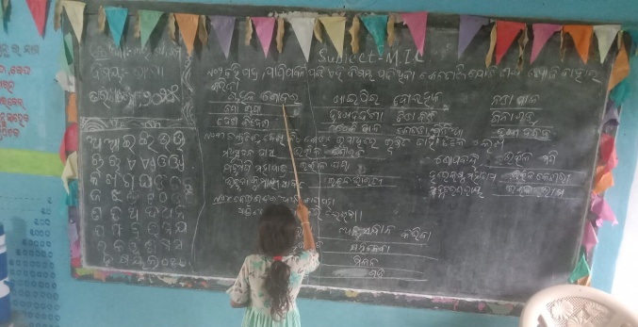
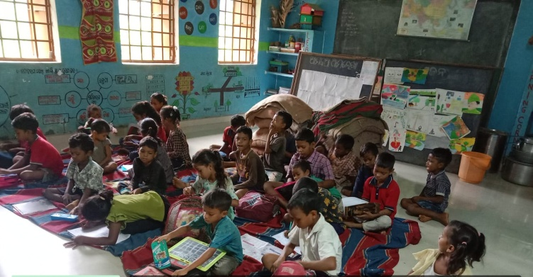
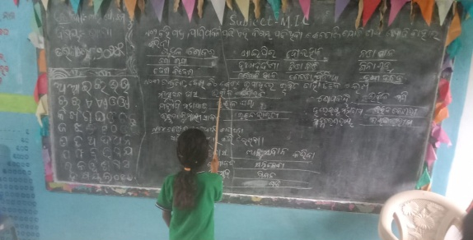
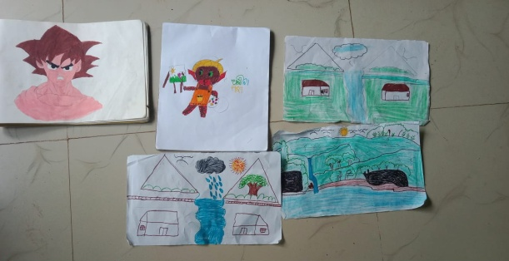
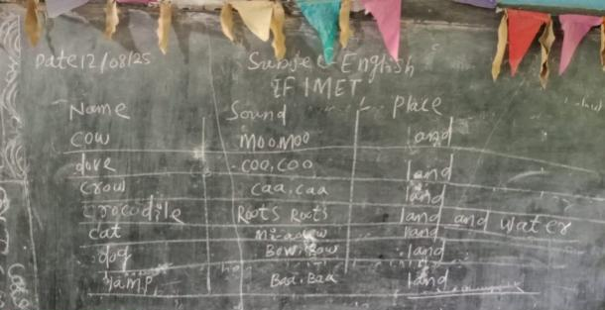
Animal Helpline- 1962
Supported by Department of Animal Husbandry, Govt of Odisha

About AHL:
AHL work for rescuing injured or abandoned animal, providing medical care, rehoming, and offering advice and resources to pet owners. AHLs often operate hotlines or online platforms where people can report animal emergencies or seek guidance on animal-related issues. These helplines play a crucial role in animal welfare and advocacy.
Animal Helpline 1962-Implemented from 2022 to 2025, the helpline addressed 2,506 accidental and emergency cases, providing timely treatment and care to injured stray animals, including cows, dogs, and other species. This played a vital role in ensuring animal welfare and reducing suffering in emergency situations.

Objective-
- Improving lives of stray, abandoned and distressed animal
Objective specific-
- To provide veterinary health care services to stray and abandoned animal on receipt of the calls from the state animal helpline call center.
Activities:
- Responding emergency calls and offer needed treatment of injured and distressed animal.
- Free ambulance service to the distressed animal as soon as possible upon receiving a call/communication.
- Shifting of sick/injured animal to the nearest appropriate facility for the necessary treatment and care.
- Proper disposal of animals recovered from the accident sites within Bhawanipatna Municipality jurisdiction with due consultation to the appropriate authority.
- Active support & coordination in the implementation of ABC programme adhering to prescribed guideline.
- Active facilitation and support in the early neutering of dogs.
- Awareness and education to build a human-animal co-existence conducive environment to achieve and sustain the desired objective.
- Spreading and propagating the existing animal laws and key messages to enhance awareness and sensitization.
- Helping the authority in gearing up the targeted animal population control initiative.
- Establishing rapport with the targeted community for the effective implementation of AHL services.
- Establish coordination and network with the like-minded organization, stake holders and individuals to ensure an enabling environment for the animal care and service.
- Maintain and update a database, impact report and document the practices and success stories on AHL programme.

Sl. No. | Month | No. of Cases
1 | April 2024 | 74
2 | May 2024 | 43
3 | June 2024 | 55
4 | July 2024 | 83
5 | August 2024 | 138
6 | September 2024 | 123
7 | October 2024 | 143
8 | November 2024 | 98
9 | December 2024 | 118
10 | January 2025 | 121
11 | February 2025 | 114
12 | March 2025 | 58
 | TOTAL | 1168
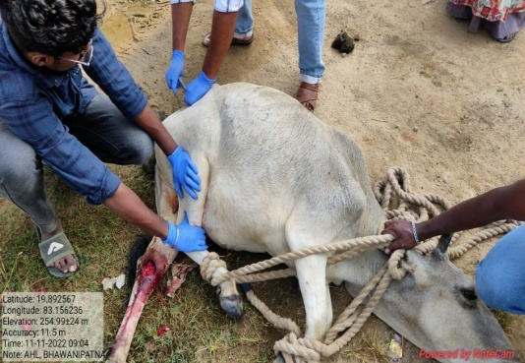
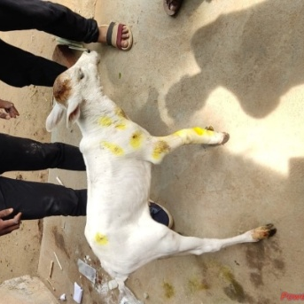
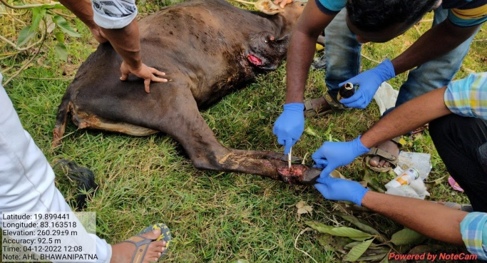
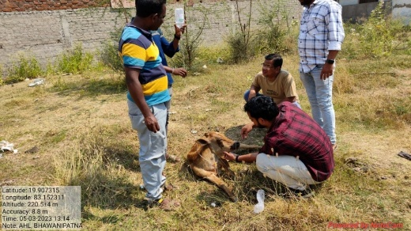
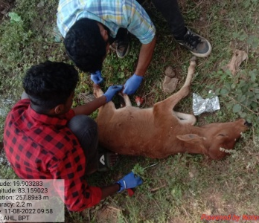
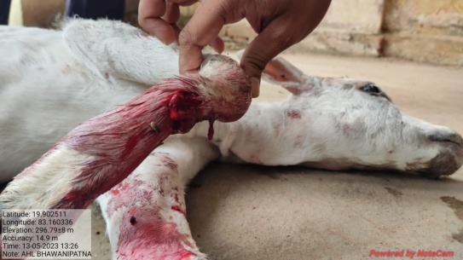

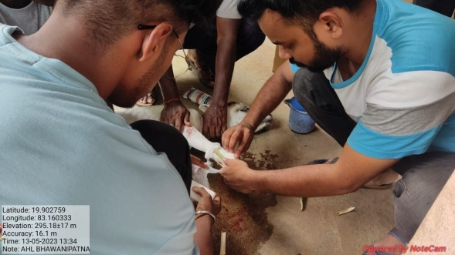

CHILDFUND
Supported by BMZ

Project Title: Protecting the rights of children by building resilience of 2000 vulnerable Households in Odisha, India.
Operational Area: 33 villages under Dharamagarh block of Kalahandi district and 11 villages under Boden block of Nuapada district.
Project duration: 36 months, 01/10/2022 to 30/09/2025
Project Objective: The resilience of 2000 vulnerable households in 88 villages in Odisha is strengthened and the rights of children are protected from the dangers of emergency migration.
Project Name “Protecting the rights of children by building resilience of 2000 vulnerable Households in Odisha, India”
A brief note on the project:
The overall objective of the project - To reduce emergency migration of small marginal land holder House Hold, improve employment of young adults and protect children affected by migration in the two districts of Kalahandi and Nuapada in the state of Odisha.
Project Objective:
Outcome: The resilience of 1000 vulnerable households in 44 villages in Odisha is strengthened and the rights of children are protected from the dangers of emergency migration, migration is reduced, dropout issues are mitigated, youths have opportunities and livelihood is promoted.
Key Achievements: -
- 139 Farmers were linked with Price of Mission benefited with Potato -150 Kg, Onion seedling - 0.5 kg to each farmer.
- 112 Farmers were linked under State Plan Scheme benefitting 5 Plastic Crate to each farmer.
- 126 Farmer were linked under National Food Security Mission (NSFM) benefitting with 4 Kg Moong to each farmer out of which 16 farmers got 4 kg Maize.
- Under CDPMLIP 353 farmers (Horticulture Dept. 40 farmers & Agriculture Dept. 313 farmers) were linked & will be benefited in cash installments in 3 years (Vegetable-19200/-, Maize-5720/-, Cotton-7920/-, Ground Nut- 9680/-, Pulses-8800/-).
- 228 indirect beneficiaries have adopted CSA farming.
- Under PDMC scheme 10 farmer got sprinkler for agriculture.
- 59 Student were enrolled in State Institution of Open Schooling (SIOS).
- 13 Students were linked under Mission Vatsalya (Green Passage) benefiting Rs4000/- per month to each student till the age of 18 years.
- 32 children were linked in Ashirwad scheme
- 1 child by linking with govt. has been kept in CCI Dharamgarh.
- 29 youth were linked through DDUGKY.
- 1 youth trained through CIPET in plastic technology and placed in blangore.
- A survey was conducted on awareness of Govt. schemes for 1000 Housse-hold, Youth & 44 VLCPC.
- Kiran Bishi a boy from Budhimunda CLC appeared the Navodaya Exam & got qualified into it.
- Ahalya Gahir a girl from Pipalpada CLC appeared the OAV (Odisha Adarsha Vidyalaya) exam & got qualified for it.
- 3 women farmers attended the mushroom training in Andhra Pradesh.
- 1 disability SHG group formed, 2 SHG group bank A/C opened & 1 SHG group receive money from the bank.
CASE STUDY
Where there’s a will, there’s a way.
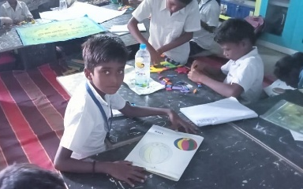
Kiran Bishi is a 12 years old child from Budhimunda village. His family consists of his father, mother & his sister. He is physically challenged as he is unable to speak & hear properly. He studies 5th standard at Budhimunda P.S. He is moderate in academics at school. Despite being challenged, he has a positive attribute for learning. After DAPTA’s intervention we identified his potential for study & the difficulty he was facing in studies. He then joined our Child learning center at Budhimunda P.S. After joining the CLC, he was taught with different TLM, action song & stories which made him more prompt & helped him to understand the lessons more. Within months he leveled up due to his determination, dedication & learning through various learning methods in our CLC. Observing his aptitude for study, the education facilitator helped Kiran Bishi for preparation of Navodaya Exam. After the releasing of Navodaya Exam Dates, Kiran filled-up the form for Navodaya. He appeared the exam on the dated 18.01.25 & waited for the results. On 27.03.25, the result was declared & Kiran Bishi successfully cleared the exams with flying colors & was selected for Navodaya. It was a great achievement for him & for us, as a challenged child learning in the CLC. We are very proud of Kiran Bishi for his outstanding achievement.
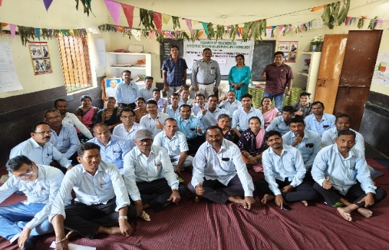
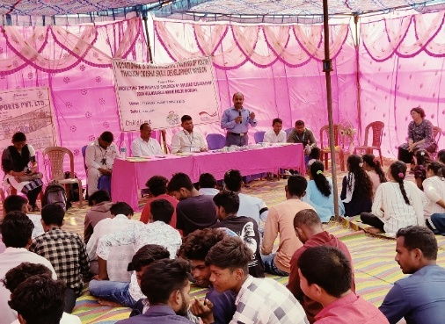
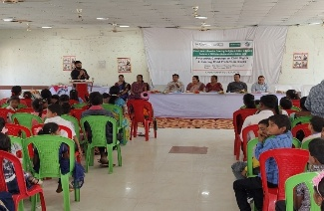
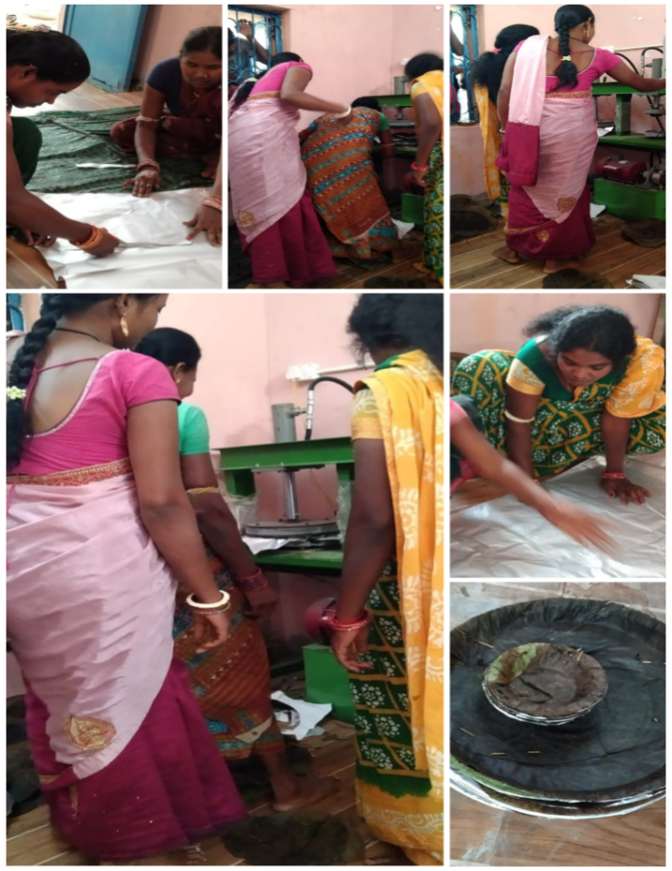
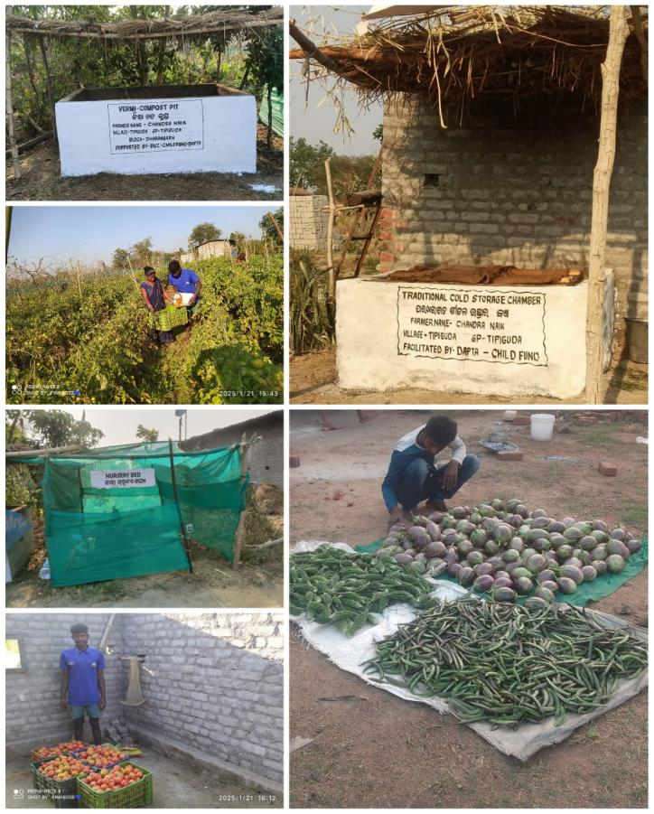
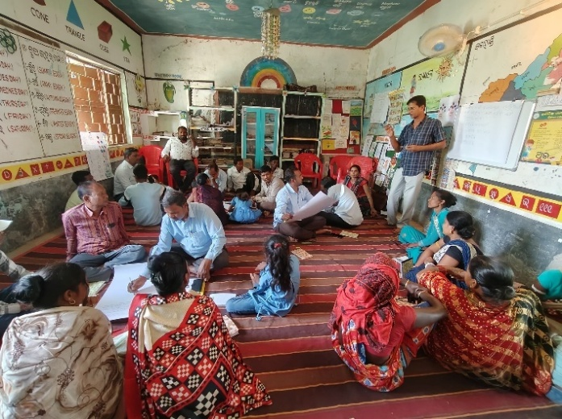
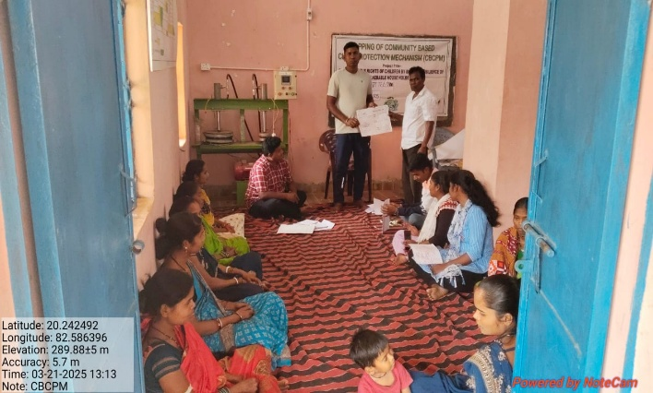
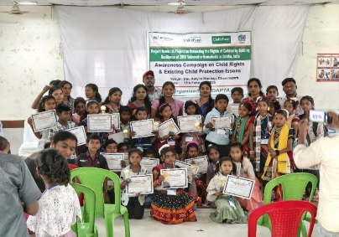

Sl. No | Full Time Office Bearer with Address | Educational Qualification | Professional Qualification | Current Designation/  Work Responsibilities | Years of Work Experiences | Area of Specialization
1. | Mrs. Alaka Nayak | M.A | Educationalist and Social Worker | President | 13 Years | Community Mobilization and  Communication n
2. | Mrs. Mamata Mohapatra  Mandar Bagichapada, Bhawanipatna,  Kalahandi. | M.A | Social Worker | Vice-President | 10 Years | Women Empowerment and Social Development
3. | Mr. Aadarsh Sharma  At- Mandar Bagicha pada  Post- Bhawanipatna Dist.- Kalahandi | B. Tech | Social Worker | Secretary cum Chief Functionary | 3 Years | Community Empowerment and social Development
4. | Mrs. Saraswati Mishra  At- Madanmohan Pada  Post- Bhawanipatna Dist.- Kalahandi | B. A | Women in Agriculture, sustainable Livelihood. | Treasurer | 15 Years | Social Development
5. | Mr. Hrudananda Majhi  At- Lakshmipur  Post- Parmanandapur Dist.- Kalahandi | B. A | Social Worker | GB Member | 15 Years | Social Development
6. | Mrs. Belmati Naik Dumal  Kamthana Bhawanipatna  Kalahandi | Matric | Community mobilization | GB Member | 12 Years | Education & Social Development
7. | Mr. Parsuram Sabar Batua  Po Gunduri Kalahandi, | Matric | Social Worker | GB Member | 12 Years | Social Development
Details of the Governing Board/Exec. Committee

No. of Male Staff | No. of Female Staff | No. of TG Staff | Total No. of Staff | No. of Paid Volunteers
82 | 38 | 05 | 125 | TG-5  Female- 50  Male- 10  Total - 65
STAFF DETAILS OF DAPTA

TRAINERS ASSOCIATED WITH DAPTA
SL.  NO. | NAME | EDUCATION QUALIFICATION | EXPERIENCE IN DEVELOPMENT SECTOR | SPECIALIZATION
1. | Dipan Kumar Sharma | M.A in sociology. | 19 years in Development sector | RCH, HIV/AIDS, Micro-plan, livelihood and Disaster management, Malaria Control State level trainer in PRI.
2. | Hrudananda Majhi | B. A | 19 years in Development sector. | Agriculture, Watershed, Micro plan and Community Management. Organic farming.
3. | Saraswati Mishra | B. A | 13 years in Development sector. | Agriculture, SHG, Micro plan, PRA, PRI and GKS, Gender Equity. Organic farming.
4. | Srimukh Pan | B. A | 11 years’ experience in Development sector. | Agriculture, SHG, PRI, Micro plan and GKS.
5. | Sujata Rani Das | M.S.W/ LLB | 20 years’ experience in Development sector | Community Development, Women Empowerment, Advocacy, Health (SRHR and HIV/AIDS), Forest & Women Law, Disaster Management, Livelihood.
6. | Sanjukta Tripathy | M.S. W | 2 years | Women Empowerment, Child right, PRI
7. | Bitan Kumar Sharma | M.A | 7 years | Women Empowerment, Livelihood, Education and Child Right
8. | Somi Singh | M.S. W | 2 years | Women Empowerment, Education and Child Right
9. | Ajay Kumar Dash | M.S. W | 2 years | Livelihood and Agriculture
10. | Somerendra Naik | M.S.W | 10 years | Health, Livelihood and Agriculture
12. | Biswanath Harijan | MSW | 6 years’ experience in Development sector | Health, Education and Livelihood

Legal Entity
Name of the Organization | DEVELOPMENT AGENCY FOR POOR & TRIBAL AWAKENING (DAPTA)
Year of  Establishment  Registration details Act.  Reg. No.- Date-  Type of organization | 15.08.1989  - Society Registration Act XXX 1860  KLD.469-20-1991  23.01.1990.  NGO – Non-Political, Secular and Nonprofit motive social service organization.  - Registered under Foreign Contribution Act.  Regd. No. -104950021. Dated-17.08.1992 and renewed on dated 01.04.2022  - Registered under Income Tax Act PAN – AAAAD2331A  TAN – BBND00682D  Regd. No-Judl/10/12A/94-95/19773. Dated- 10.09.1995 and renewed on dated 28.05.2021 bearing number-AAAAD2331AE20214  - Registered under 80G of Income Tax Act  Regd. No- Judl/119/80G/1995-96/15855. Dated-24.10.1995 & renewed on 28.05.2021 bearing number AAAAD2331AF20214  Regd. No-CIT/SBP/Tech./80-G/2011-12/304 Dated, Sambalpur, the 19th April, 2011 and renewed on dated 28.05.2021  Regd under Nitti Aayog- OR/2016/0101255  Regd under CSR 1- CSR 00006456 of dated 22/05/21

We convey our heartfelt gratitude to all friends, well-wishers, donors and resource agencies and above all the community we work with for their kind & benevolent support and cooperation and travelling with us in the development journey.
Our Bankers
Our Auditor
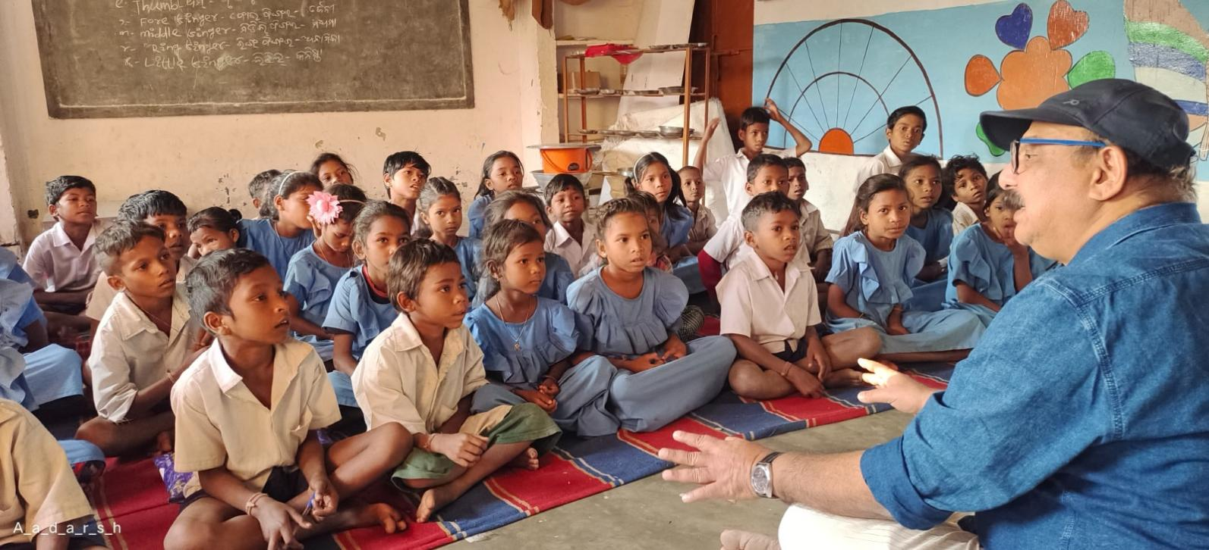
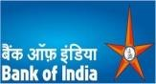  Bank of India Palace Road Bhawanipatna PIN-766001  Dist.- Kalahandi |   Canara Bank  Bhawanipatna, Kalahandi |   State Bank of  India,  NDMB Parliament Street, New Delhi |   C.A. Pankaj Jain Mob No. 8895405797  BHAWANIPATNA, Kalahandi  ODISHA- 766001

Act of sacrifice, charity and penance
Are not to given/up
They must be performed
Indeed, Sacrifice, Charity and penance
Purity the great soul.

Aadarsh Sharma,
Secretary, DAPTA
Annual Report-DAPTA 2024-25

